DEVOPS

**DAY-1**

It Is a culture that improves the organizations ability to deliver the application.

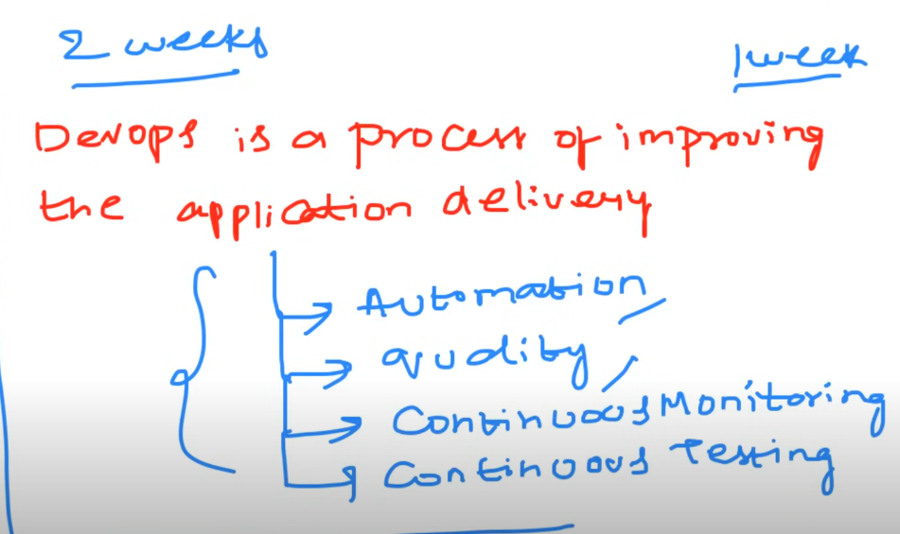

Devops is a process of of improving the application deliverey by ensuring automation,quality, monitorimg ,testing

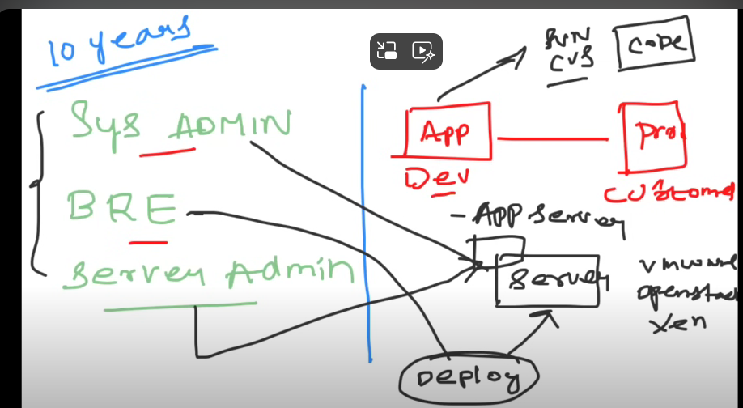

(Before 10years first app is craeted by developer. He will pace in central repo like github,svn..etc.next system admin will create a server in virtualmachine(vmware)(aws was not there).next Bre(build and release engineer) deploy the app from git to app server. Server admin will create application server in server.in that bre deploy the app. Application server is the server which holds application in server.)

**1. Application Development & Version Control**

* **Developer Creates the Application**: A developer writes the code for an application. This could be any type of application, such as a web app, desktop app, or mobile app.
* **Central Repository (e.g., GitHub, SVN)**: Once the code is ready, the developer pushes the code to a central version control repository like GitHub or SVN (Subversion). This repository acts as a centralized location where the code is stored, tracked, and shared with other team members.

**2. Server Setup by System Administrator**

* **System Admin Creates a Server**: At this point, cloud services like AWS were not available, so a physical server or a virtual machine (VM) was used. The System Administrator (SysAdmin) would either physically set up a server or use virtualization software like VMware to create a virtual machine that could host the application.
* **VMware (or similar)**: VMware was a popular tool for creating and managing virtual machines on physical hardware. The SysAdmin would use VMware to spin up a virtual server, which is essentially an isolated environment that behaves like a separate physical machine.

**3. Build and Release Engineer (BRE) Involvement**

* **Role of BRE**: The Build and Release Engineer (BRE) is responsible for automating the build process and deploying the application to the server. The BRE's role includes managing the build scripts, resolving dependencies, and ensuring that the application is correctly packaged and ready for deployment.
* **Deploying from Version Control to Server**: The BRE would pull the latest code from the central repository (e.g., GitHub or SVN) and prepare it for deployment. This could involve compiling the code (if necessary), running tests, packaging the application into a deployable format (like a WAR file for Java applications), and finally deploying it to the application server.

**4. Application Server Setup by SysAdmin**

* **Application Server Creation**: The SysAdmin is responsible for setting up the application server. An application server is a software framework that provides an environment for running specific applications, often web-based. Common examples include Apache Tomcat, JBoss, or WebSphere.
* **Installing and Configuring the Application Server**: The SysAdmin would install the application server software on the virtual machine. They would then configure it to ensure it’s ready to host the application. This might involve setting up the correct runtime environment, managing resources like memory and CPU allocation, and configuring network settings like ports and IP addresses.

**5. Deployment of the Application**

* **BRE Deploys the Application**: Once the application server is ready, the BRE would deploy the application to the server. This could be done manually by copying files to specific directories on the server or through automated scripts that handle the deployment process.
* **Running the Application**: After deployment, the application would be live on the server. The application server would manage the lifecycle of the application, handling requests from users, running the application logic, and serving content to clients.

**6. Post-Deployment Management**

* **Monitoring and Maintenance**: After the application is deployed, both the SysAdmin and the BRE might be involved in monitoring the server and the application. This could include checking server performance, handling any issues that arise, and performing regular maintenance like applying security patches or updating the application.

VIRTUAL MACHINE

Let's clarify the concepts of VMware, virtual machines (VMs), and how they compare to cloud services like AWS, using real-world examples.

**1. VMware and Virtual Machines (VMs)**

* **VMware**: VMware is a company that provides virtualization software. The most relevant products here are **VMware Workstation**, **VMware ESXi**, and **VMware vSphere**, which allow you to create and manage virtual machines on physical hardware.
* **Virtual Machine (VM)**: A VM is a software-based emulation of a physical computer. It runs an operating system and applications just like a physical machine but shares the underlying physical hardware with other VMs.

**Real-World Example:**

* **Your Computer Setup**:
  + **Without VMware**: You might be running Windows 10 on a laptop with 16 GB RAM. You can run multiple applications, but they all share the same OS and resources.
  + **With VMware**: You install VMware Workstation on your Windows laptop. Now, you can create a VM running Ubuntu within your Windows environment. You allocate 8 GB of RAM and 2 CPU cores to this VM. Now, you have Windows 10 and Ubuntu running simultaneously on the same physical laptop, but isolated from each other.

**Example Using VMware:**

Imagine you have a powerful physical server in your office. This server has a lot of CPU power, RAM, and storage. Instead of using this server to run just one application, you can use VMware to create multiple virtual machines on this single physical server. Each VM can have its own operating system and run its own applications.

* **Scenario**: You have a physical server with 64 GB of RAM and 16 CPU cores.
  + **VM 1**: Runs a Windows Server with 16 GB RAM and 4 CPU cores, hosting a web application.
  + **VM 2**: Runs an Ubuntu server with 16 GB RAM and 4 CPU cores, hosting a database.
  + **VM 3**: Runs a CentOS server with 32 GB RAM and 8 CPU cores, handling file storage.

Each VM is isolated from the others, meaning if one crashes, it doesn’t affect the others. You can also easily move VMs between physical servers using VMware tools, providing flexibility and disaster recovery options.

**2. AWS (Amazon Web Services)**

* **AWS Overview**: AWS is a cloud computing platform that provides a wide range of services, including computing power, storage, databases, and networking. Instead of managing physical servers and virtualization software yourself, AWS does this for you in the cloud.
* **Elastic Compute Cloud (EC2)**: In AWS, the equivalent of a VM is called an EC2 instance. You can launch an EC2 instance with a few clicks, choosing the amount of CPU, memory, storage, and the operating system you need.

**Example Using AWS EC2:**

Imagine you want to run the same applications as in the VMware example, but you don’t want to manage the physical hardware yourself.

* **Scenario**:
  + **EC2 Instance 1**: You launch an EC2 instance with Windows Server, 16 GB RAM, and 4 vCPUs (virtual CPUs) to host your web application.
  + **EC2 Instance 2**: You launch another EC2 instance with Ubuntu, 16 GB RAM, and 4 vCPUs to host your database.
  + **EC2 Instance 3**: You launch a third EC2 instance with CentOS, 32 GB RAM, and 8 vCPUs for file storage.

**Comparison: VMware vs. AWS**

* **Infrastructure Ownership**:
  + **VMware**: You own the physical hardware and the VMware software. You are responsible for maintaining and managing the servers, storage, networking, and virtualization.
  + **AWS**: AWS owns the physical infrastructure, and you rent computing resources. AWS manages the underlying hardware, and you only focus on managing your virtual instances.
* **Scalability**:
  + **VMware**: Scaling requires purchasing more physical hardware and setting it up in your data center.
  + **AWS**: Scaling is instant and flexible. You can launch more instances or resize existing ones in minutes without worrying about physical hardware.
* **Cost**:
  + **VMware**: High upfront costs for purchasing and maintaining hardware and software licenses. Operational costs include electricity, cooling, and maintenance.
  + **AWS**: Pay-as-you-go pricing. You only pay for the resources you use, with no upfront hardware costs. AWS manages the infrastructure, reducing operational expenses.
* **Maintenance**:
  + **VMware**: You are responsible for maintaining the physical hardware, updating the VMware software, and handling any hardware failures.
  + **AWS**: AWS handles all maintenance, including hardware repairs, software updates, and scaling. You focus on your applications.

**Real-Time Example:**

Imagine a company wants to host an e-commerce platform.

* **With VMware**:
  + The company buys a physical server, installs VMware, and creates several VMs: one for the website, one for the database, and one for load balancing.
  + The company’s IT team manages the server room, ensures everything is running smoothly, and handles any issues with the hardware.
* **With AWS**:
  + The company launches EC2 instances on AWS: one for the website, one for the database, and one for load balancing.
  + The company’s IT team focuses on managing the software, while AWS handles all the hardware, scaling, and availability. The company pays only for the resources they use, and can easily scale up during high traffic periods like Black Friday.

This real-time example illustrates how AWS abstracts away the complexity of managing physical infrastructure, allowing companies to focus more on their core business and less on maintaining hardware.

**NOW TO** IMPROVE **THIS PROCESS NOW EVERY MOVED TO DEVOPS for to improve process of delievery.**

**DevOps is a combination of cultural philosophies, practices, and tools that aims to improve an organization's ability to deliver applications and services at high velocity. It bridges the gap between the development (Dev) and operations (Ops) teams by fostering collaboration, automation, and continuous delivery. The ultimate goal of DevOps is to shorten the development lifecycle while ensuring high quality and frequent releases.**

**DAY-2**

SDLC: it is a process used by software industry to design, develop and test. At last the end goal is to deliever high quality product.

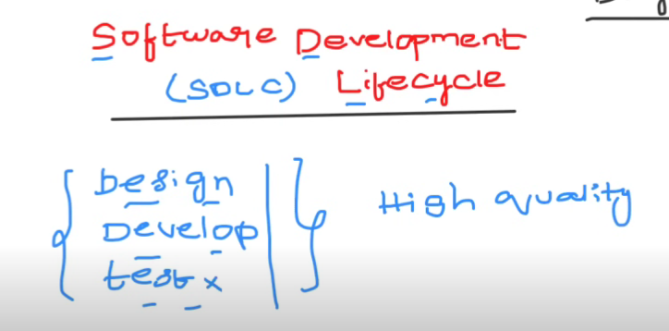

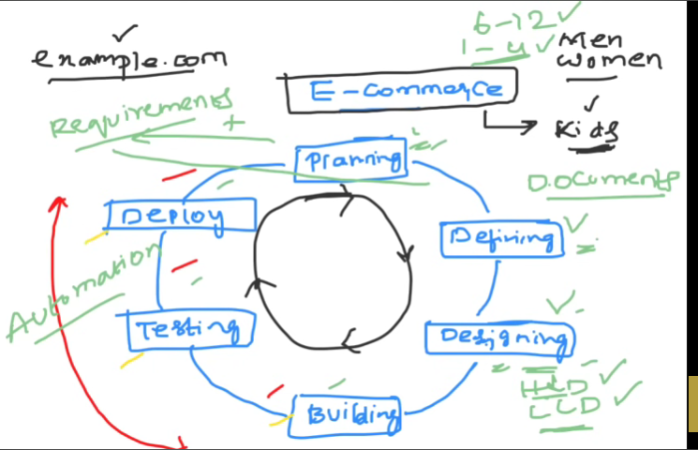

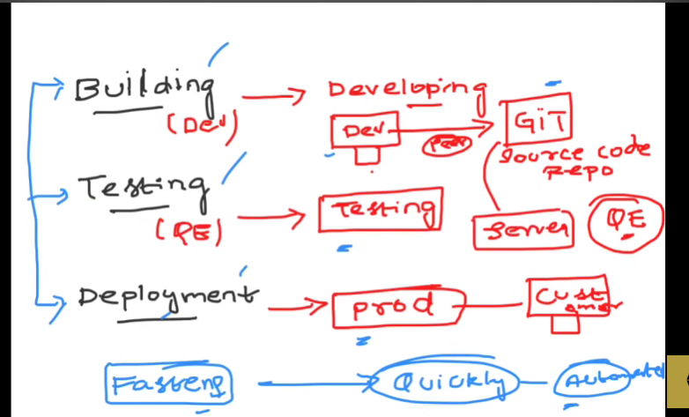

Developer build the application In their local machine and pushed into the git. Next another developer took that prj and placed in the then server. Next test will test the project in that server. If it is good then it will be plced in the prod server.

**DAY-3: VIRTUALIZATION**

**See what Is servers in youtube?**

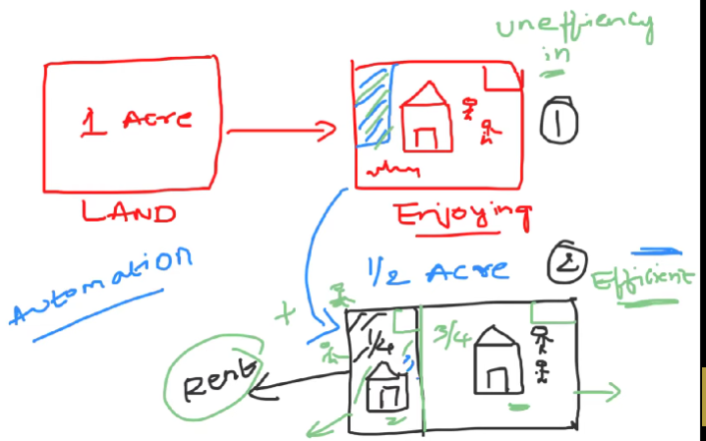

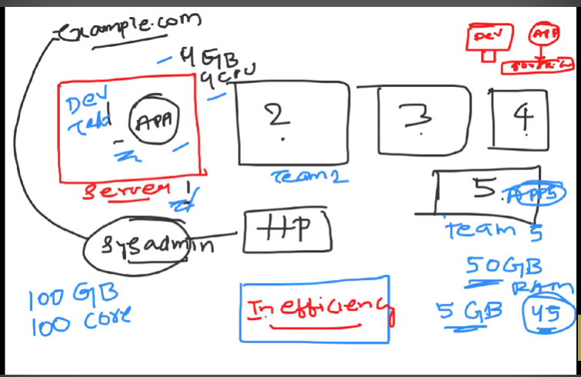

**Here I have 5 servers . each server has capacity of 100gb, 100cpus and but it is allowed to run only one app in one sever. So . That app can take space 4gb,4pu. 5apps and 5 servers . in each server some place is wasted. That’s why virtualization came into picture.**

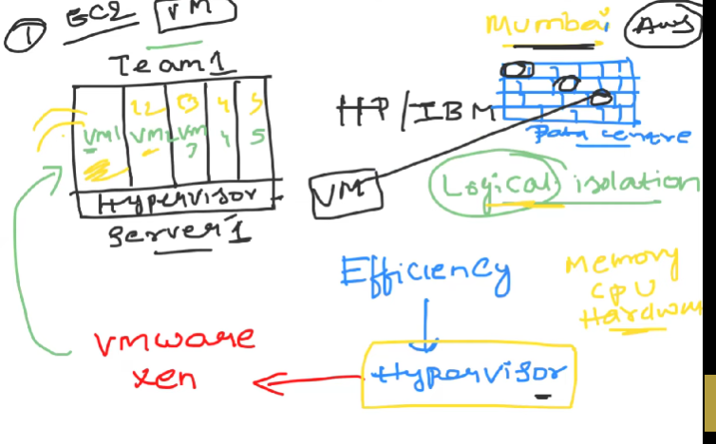**Here in computer we install hypervisor software. This software will install virtual machines. We partioning logical1y. popular hypervisors are vmware,xen. Here each vairtual machine has there own memory,cpu..etc..these are logical servers.**

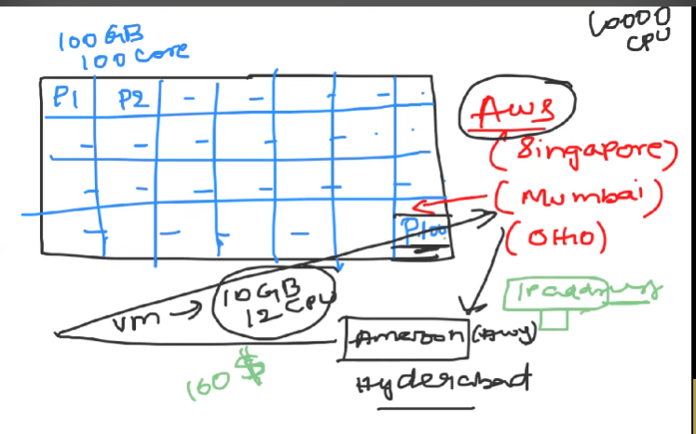

**DAY-4**

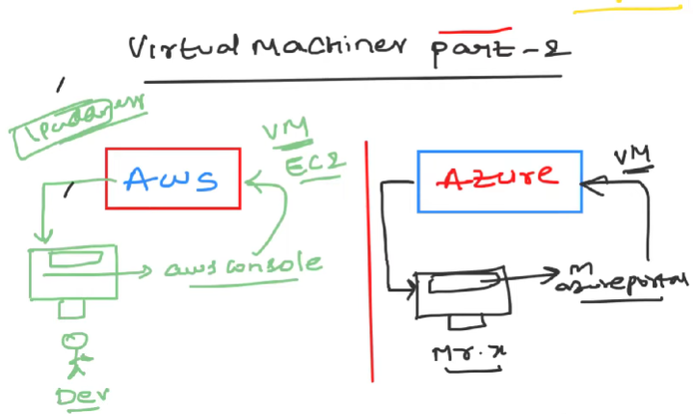

**Actually first developer will get request createe virtual machine(ec2) in aws. Everytime he will llogin into aws console and create the ec2. Sanme like Azure. It is manula process . if you get 100requests to create ec2’s.every time developer has to go 100times to aws console and create s the ec2. It is not efficent.in order to make efficient.the devops emgineer instead of directly acessing the aws console what he will do is.he would write a script. Using this script he would make a call to the “aws ec2 api”. In this script what he will do is I want to create 10ec2 instamces or whenever user ask to create ec2 , he has to run the script and return ec2 instance. We writing script to automatically creating script.**

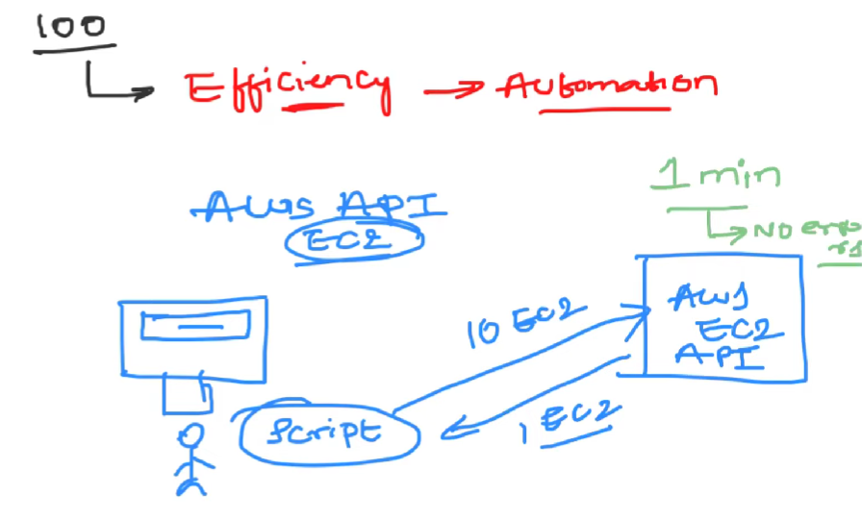

**When a developer receives a request to create an EC2 instance on AWS, they typically log into the AWS Management Console and manually create the instance. This process works fine if the number of requests is small. However, if the developer receives many requests (e.g., 100 requests), manually logging in and creating each EC2 instance can be time-consuming and inefficient.**

**The Solution:**

**To automate this process, a DevOps engineer can write a script that interacts with the AWS EC2 API. This script allows the creation of EC2 instances without manually logging into the AWS console. The script can be configured to handle multiple requests efficiently.**

**How It Works:**

1. **AWS EC2 API: AWS provides an API that allows you to perform various actions programmatically, such as creating, managing, and terminating EC2 instances. Instead of using the AWS Management Console, the script will use this API to interact with AWS services.**
2. **Writing the Script:**
   * **The script can be written in various programming languages, like Python, using AWS SDKs (e.g., boto3 for Python).**
   * **The script will include code to:**
     + **Authenticate with AWS using access keys or IAM roles.**
     + **Specify the configuration for the EC2 instance (e.g., instance type, AMI ID, security groups).**
     + **Make an API call to create the EC2 instance.**
     + **Return details of the created EC2 instance, such as the instance ID and IP address.**
3. **Example Workflow:**
   * **The DevOps engineer writes a script called create_ec2_instances.py.**
   * **The script takes input parameters, such as the number of EC2 instances to create.**
   * **The engineer runs the script whenever there is a request to create EC2 instances.**
   * **The script calls the AWS EC2 API to create the requested number of instances.**
   * **Once the instances are created, the script provides the developer with details of the instances.**
4. **Automation at Scale:**
   * **If there are 100 requests, the DevOps engineer doesn’t need to log in 100 times.**
   * **They can modify the script to handle bulk requests, such as creating 100 instances in one go.**
   * **This makes the process more efficient and reduces the chances of errors.**

**Example Code (Python with boto3):**

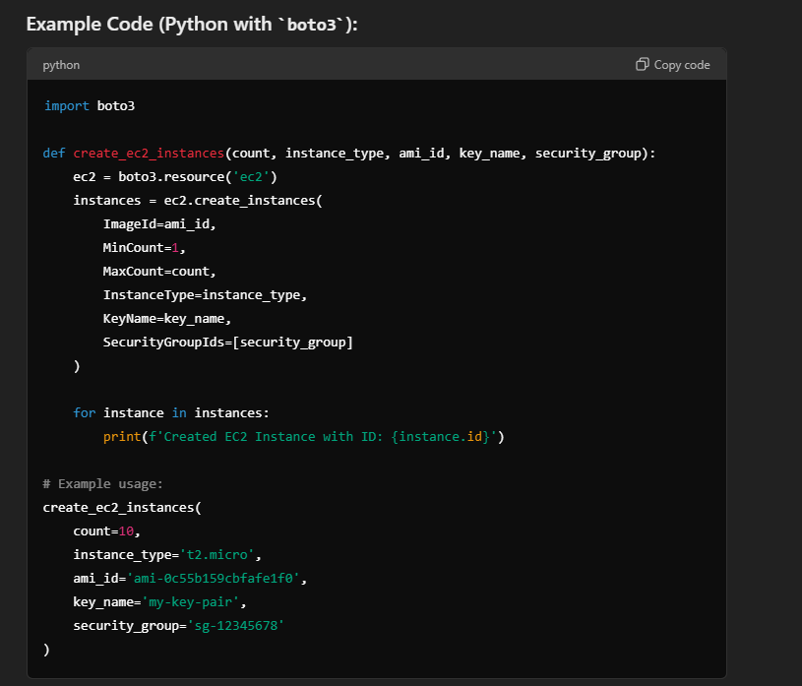

**API**

**API (Application Programming Interface):**

* **Definition: An API is a set of rules and protocols for interacting with an application or service. It specifies how different software components should communicate.**
* **Role: An API can consist of one or more endpoints that provide specific functionalities.**

**Not exactly. The entire Spring Boot application is not considered a single API but rather a framework that can host multiple APIs. Let’s clarify the distinctions:**

**Components:**

1. **Spring Boot Application:**
   * **Definition: A Spring Boot application is a standalone Java application that sets up and runs a web server, managing configurations, dependencies, and application context.**
   * **Role: It serves as the host for one or more APIs, handling requests, processing them, and sending responses.**
2. **API (Application Programming Interface):**
   * **Definition: An API is a set of rules and protocols for interacting with an application or service. It specifies how different software components should communicate.**
   * **Role: An API can consist of one or more endpoints that provide specific functionalities.**
3. **API Endpoint:**
   * **Definition: An endpoint is a specific URL within an API that allows clients to perform operations like retrieving, creating, or updating data.**
   * **Role: Each endpoint provides a distinct functionality or data access point.**

**Example Breakdown:**

**1. Spring Boot Application:**

* **DemoApplication class starts the application and configures the environment.**
* **Overall Framework: Provides the infrastructure to handle HTTP requests and route them to the appropriate controllers.**

**2. API:**

* **Definition: A collection of endpoints exposed by the Spring Boot application.**
* **Example: The weather service API that includes endpoints for current weather, forecasts, etc.**

**3. API Endpoint:**

* **Definition: A specific URL path in the API.**
* **Example:**
  + **Endpoint: /api/greeting**
  + **Function: Provides a greeting message when accessed via an HTTP GET request.**

**In a Spring Boot Application:**

* **Multiple Endpoints: A single application can have multiple endpoints. For example, you might have:**
  + **GET /api/greeting**
  + **POST /api/users**
  + **GET /api/weather**

**Each endpoint is a part of the overall API offered by the application.**

* **Single Endpoint Example:**
  + **In the provided Spring Boot example, /api/greeting is one endpoint of the API exposed by the application.**

**Summary:**

* **Spring Boot Application: Hosts and manages APIs and their endpoints.**
* **API: Comprises one or more endpoints.**
* **API Endpoint: A specific URL that performs a particular action or provides specific data.**

**Thus, while a Spring Boot application provides the framework to support APIs, it is not a single API itself but rather a platform that can expose multiple APIs and their respective endpoints.**

**Yes, a collection of multiple endpoints can be considered one API. Here’s a more detailed breakdown:**

**Concept of an API**

1. **API (Application Programming Interface):**
   * **Definition: An API is a set of rules and protocols that allows different software applications to communicate with each other. It defines how requests and responses should be structured and what operations can be performed.**
   * **Scope: An API is a broad concept that includes multiple endpoints, each providing a specific functionality or accessing a different resource.**

**Collection of Endpoints**

* **Endpoints:**
  + **Definition: An endpoint is a specific URL path exposed by the API that allows clients to perform operations (e.g., retrieving, creating, updating, deleting data).**
  + **Example: For a weather API, endpoints might include:**
    - **GET /api/weather/current (fetch current weather)**
    - **GET /api/weather/forecast (fetch weather forecast)**
    - **POST /api/weather/report (submit a weather report)**
* **API with Multiple Endpoints:**
  + **Definition: A single API can expose multiple endpoints, each serving a different purpose or handling a different type of request.**
  + **Example: The weather API mentioned above is a single API that includes multiple endpoints. Each endpoint provides access to a different aspect of the weather service.**

**Example in a Spring Boot Application**

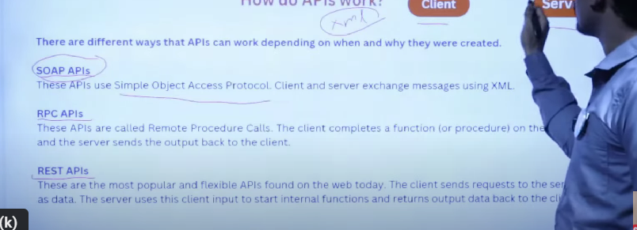**In a Spring Boot application, you can have multiple controllers, each with its own set of endpoints. Together, these endpoints form the complete API of the application.**

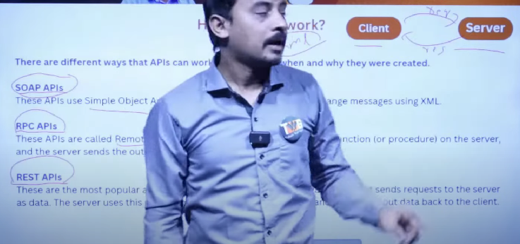**HERE REST API, SOAP API, RPC API these are way of representing API. These are architectural patterns . nothing but types of representing an API.**

**If you are using REST API we have to follow these rukes.**

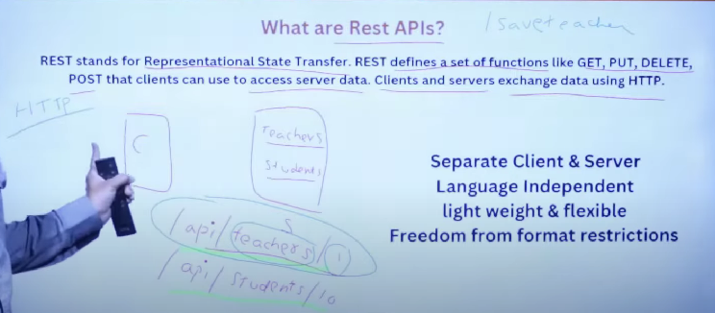

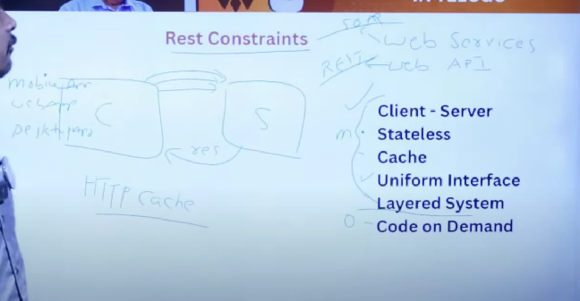

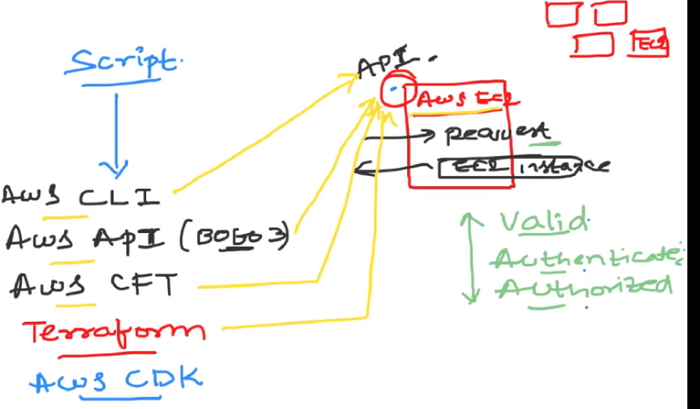

**By using the script in any of four we can call AWS API for creating an and return response as ec2.**

**We can create ec2 intsance in aws console. And we can connect to EC2 instance by uisng AWS terminal. If u leave and go way from terminal it automatically disconnected that ec2. Instead of that developers uses the terminal for connecting to ec2 . They are putty, mobexgterm, nomachine..etc for windows and for mac we use iterm2 terminal. For these we have to provide public IP and keypair also.**

**Till now we we are creating Ec2 instances by manually .by opening Aws console and creating Ec2.**

**Now onwards we automate the process by running scripts. For that we have four options .1) AwsCLi.2)Aws api 3)Aws cft 4)terafform 5)aws cdk**

**Now we will go through all these four options.**

**AWS CLI(command line interface):**

**Aws cli is a command line interface. Using this cli,we can directly interact with Aws api or to Aws account and create any resource in Aws.**

**So download Aws Cli from google. Next we have to connect to aws .that means we have to give some credtionals to AWS CLI to connect with aws adccount. After connecting, if u enter commands it will reflect in u r aws account. If u give command to create EC2 . it woill create ec2 in u r aws cloud account.**

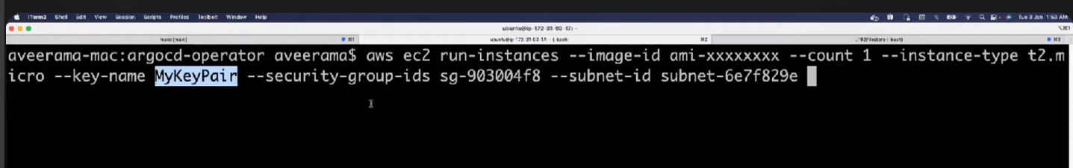

**Creating ec2 we have command. It is Iterm2 terminal. For Mac.**

**DAY-6**

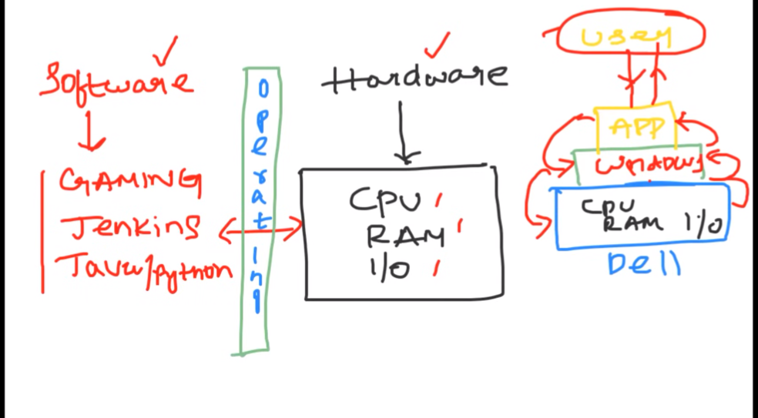

Normally we buy server. That is haedware . we cannot run the run applicarions directly in server. That should understand what we are telling. For that it has operating system, RAM hardisk(i/o). here operatig system Is like bridge between your applications and hardware. Ex jenkins we will install in server harddisk. Jenkins will send request to hardware through operating. because hardware knows only binary languguage. Os converts the request and send to hardware.

**Understanding How Servers Work with Applications and Operating Systems**

When you purchase a server, you're essentially acquiring a powerful computer designed to run various applications and services. However, to effectively run these applications, the server needs an operating system (OS). Let’s break down how this process works.

**1. Server Hardware**

* **Components:**
  + **CPU (Central Processing Unit):** The brain of the server that performs calculations and processes instructions.
  + **RAM (Random Access Memory):** Temporary storage used by the CPU to store data that is actively being used or processed.
  + **Hard Disk (Storage):** Permanent storage where the OS, applications, and data are stored.
  + **I/O (Input/Output):** Handles communication between the server and external devices (e.g., network interfaces, storage devices).

**2. Operating System (OS)**

* **Role of the OS:**
  + The OS acts as an intermediary between the hardware and the applications running on the server.
  + It manages hardware resources like CPU, memory, and storage.
  + The OS translates the high-level commands from applications into low-level instructions that the hardware can understand and execute.
* **Example:**
  + If you want to run Jenkins (a CI/CD tool) on your server, you would first install an OS (e.g., Linux, Windows Server) on the server's hard disk.
  + The OS provides a platform for Jenkins to run and interact with the server's hardware.

**3. Running Applications on a Server**

* **Application Installation:**
  + After the OS is installed, you can install applications like Jenkins on the server.
  + The application is stored on the server’s hard disk, and when you run it, the OS loads it into RAM for execution.
* **How Applications Interact with Hardware:**
  + **Application Request:** When Jenkins performs an action (e.g., building a software project), it makes requests that need to be processed by the CPU, stored in memory, or saved to disk.
  + **OS Translation:** The OS receives these high-level requests and converts them into low-level machine code (binary language) that the CPU can understand.
  + **Hardware Execution:** The CPU processes these instructions, and the OS manages how the data is stored in RAM or written to the hard disk.

**4. Example Flow: Running Jenkins on a Server**

1. **Jenkins Installation:**
   * You install Jenkins on a server with an OS like Ubuntu (Linux).
   * Jenkins files are stored on the server’s hard disk.
2. **Running Jenkins:**
   * When Jenkins runs, the OS loads it into RAM and allocates CPU resources to it.
   * Jenkins performs tasks like building software, and these tasks involve reading/writing data, processing code, etc.
3. **Hardware Interaction:**
   * Jenkins sends a request to read a file from disk.
   * The OS receives this request, translates it into machine code, and instructs the hard disk to retrieve the file.
   * The OS then passes the retrieved file back to Jenkins.

**5. Importance of the OS**

* **Bridge Between Software and Hardware:** Without the OS, the server’s hardware wouldn't know how to interpret the high-level commands from applications. The OS ensures that these commands are translated into something the hardware can execute.
* **Resource Management:** The OS manages the server's resources, ensuring that applications like Jenkins can run smoothly without conflicts.

**Summary**

* **Server Hardware:** The physical components like CPU, RAM, and hard disk.
* **Operating System (OS):** Acts as a bridge between the server hardware and the applications, translating high-level commands into machine code.
* **Applications:** Installed on the OS and interact with hardware through the OS to perform tasks.

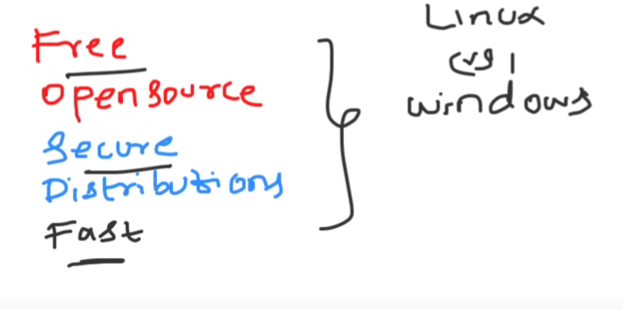By understanding this flow, you can see how the OS is crucial in enabling your applications to interact with the server hardware efficiently.

Why linux is powerful .

Architecture of Linux.

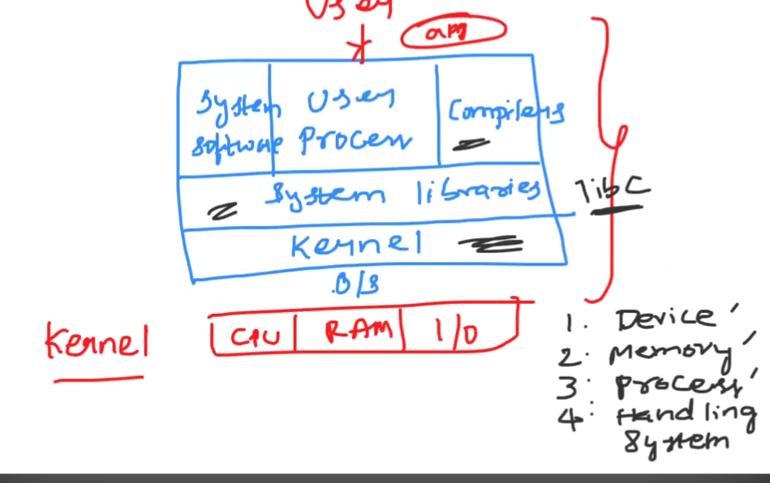

**SHELL SCRIPTING:**

Shell is the way that you talk to your operating system. If u want to create a file.if u are using windows ,in windows we have a graphical interface we do simply. Most of them working in software organization u don’t have a graphical user interfacxe for your servers. If u have issue on u r production server .you don’t have a graphical user interface for you to navigative through the folders to understand what is issue.so you have to do it through some command line way.this command line way through which you talk to u r operating system are nothing but u shell commands. On linux operating system, GUI is not installed because it comes with some weight. If u want to install graphical user interface again u r operating system or u r server would become heavy so that’s why on u r production system we don’t use GUI. AND MOST OF THE TIMES we make use of shell commands to talk to the distribution for to create files or to create anything in your operating system.shell is most of times like 99.9% of them your servers that are using on your production or Dev or Staging environments . default come with shell environments. So you can if u aware of shell commands , u can directly talk to u r linux Operating systems. And these commands common across different distributions whether u are using CENT OS ,wheather u are using FEDRO, or Whether u r using DEBAIN or Ubuntu so there are shell commands that we are going to talk. Which we use as a devops engineer are mostly common across different distributions

**Understanding Shell and Shell Scripting:**

1. **What is a Shell?(shell means CLI)**
   * The **shell** is a program that acts as an interface between the user and the operating system. It allows users to execute commands, run scripts, and perform tasks by typing commands into a command-line interface (CLI).
   * On Linux and UNIX systems, common shells include **Bash (Bourne Again Shell)**, **Zsh**, and **Sh**.
2. **Why Use a Shell Instead of a GUI?**
   * **Graphical User Interface (GUI):** While operating systems like Windows often use a GUI, many Linux servers, especially in production environments, do not have a GUI installed. This is because:
     + **Resource Efficiency:** GUIs consume more system resources (CPU, RAM, storage). Servers are often optimized for performance, so avoiding the overhead of a GUI keeps the system lean.
     + **Security and Stability:** Removing the GUI reduces the attack surface and potential vulnerabilities. It also minimizes software that could cause instability.
   * **Command-Line Interface (CLI):** Instead of using a GUI, administrators use the CLI to interact with the server. The CLI allows for precise control and automation, which is crucial for managing servers efficiently.
3. **Shell Commands:**
   * **Purpose:** Shell commands allow users to interact with the operating system directly through the CLI. These commands can do anything from creating files, managing directories, and installing software, to monitoring system performance.
   * **Examples:** Commands like ls (list directory contents), cd (change directory), cp (copy files), and mkdir (make directory) are basic examples of shell commands.
4. **Shell Scripting:**
   * **Definition:** Shell scripting involves writing a series of shell commands in a file (a script) that can be executed as a program. This is useful for automating repetitive tasks, managing system configurations, or processing data.
   * **Advantages:** Shell scripts can be used to automate complex tasks that would be tedious to perform manually. They are widely used in system administration, DevOps, and server management.

**Summary:**

* **Shell:** A command-line interface that lets you interact with your operating system.
* **Why Use CLI in Servers:** Most production servers do not use a GUI because it consumes more resources and can introduce security risks. Instead, administrators use shell commands to manage the system.
* **Shell Scripting:** Writing scripts with shell commands to automate tasks and manage systems more efficiently.

Your explanation is on the right track, and with these refinements, it accurately describes why shell commands and shell scripting are so important in managing Linux servers.

Now we will use putty or Mobexterm to connect with servers.

**Shell Environments on Servers:**

1. **Default Shell on Servers:**
   * **Linux Servers:** In most cases, whether you are working in a production, development (Dev), or staging environment, Linux servers come with a **shell environment** by default. This is true across nearly all Linux distributions.
   * **Access:** If you are familiar with shell commands, you can directly interact with the Linux operating system on these servers through the command-line interface (CLI). This is a key skill for DevOps engineers and system administrators.
2. **Consistency Across Distributions:**
   * **Common Shell Commands:** The basic shell commands (like ls, cd, cp, mv, etc.) are consistent across different Linux distributions, such as CentOS, Fedora, Debian, and Ubuntu. This consistency means that if you learn shell commands on one distribution, you can use those same commands on others with little to no modification.
   * **Shell Environment:** Most Linux distributions use **Bash** (Bourne Again Shell) as the default shell, though others like **Zsh** or **Sh** may also be used. Regardless of the specific shell, the core commands and scripting capabilities are very similar.
3. **Importance in DevOps:**
   * **DevOps and Shell:** As a DevOps engineer, proficiency in shell commands and scripting is crucial because these commands are used for automating tasks, managing servers, and deploying applications. Since these commands are common across different distributions, learning them gives you a versatile skill set that is applicable in various environments.

**Summary:**

* **Shell Environment:** Nearly all Linux servers, whether in production, development, or staging, come with a shell environment by default.
* **Consistency Across Distributions:** The shell commands you use are generally the same across different Linux distributions, making them a universal tool for managing Linux systems.
* **DevOps Relevance:** Shell commands and scripting are essential skills for DevOps engineers, allowing for efficient system management and automation across diverse environments.

Your explanation captures the key points, and with these adjustments, it should be clear and accurate for someone learning about the role of the shell in different Linux environments.

Correct, **PuTTY** and **MobaXterm** are not CLIs themselves; they are **tools** that provide you with access to the CLI on remote Linux servers.

**Clarification:**

1. **PuTTY and MobaXterm:**
   * **Tools:** PuTTY and MobaXterm are software applications that allow you to establish a remote connection to a Linux server using protocols like SSH (Secure Shell).
   * **Purpose:** They enable you to access the command-line interface (CLI) of a Linux server from a Windows machine or other environments where you may not have direct access to the Linux system.
2. **CLI (Command-Line Interface):**
   * **On the Linux Server:** The CLI is the environment on the Linux server where you interact with the shell (e.g., Bash, Zsh). The shell is the program that interprets your commands.
   * **Accessing the CLI:** When you connect to a Linux server using PuTTY or MobaXterm, you are given a window where you can type commands. This window is connected to the CLI of the remote server, allowing you to interact with the server's shell.

**Summary:**

* **PuTTY and MobaXterm** are tools that help you connect to the CLI of a remote Linux server.
* The **CLI** is actually on the Linux server itself, where the shell interprets and executes your commands.
* These tools simply act as a bridge, enabling you to use the CLI from a remote location.

**Distributions**

**What is a Distribution?**

A **distribution** (often called a "distro") is a complete operating system built around the Linux kernel. The Linux kernel is the core of the operating system that interacts with the hardware, but by itself, it’s not a complete OS. To create a fully functional operating system, the kernel is combined with various software packages, tools, user interfaces, and configurations. This complete package is what we call a "distribution."

**Why Do Distributions Exist?**

The Linux kernel is open-source, meaning anyone can view, modify, and distribute it. This openness allows different groups—whether they are companies, communities, or individuals—to take the kernel and build their own operating systems by selecting and configuring the software that best suits their needs. These different combinations result in various Linux distributions, each tailored for specific purposes or audiences.

**Components of a Distribution**

Here’s what typically makes up a distribution:

1. **Linux Kernel:**
   * The core of the operating system that manages hardware resources and enables communication between hardware and software.
2. **Package Management System:**
   * A system that handles installing, updating, and removing software. Examples include:
     + **APT** for Debian-based systems like Ubuntu.
     + **YUM/DNF** for Red Hat-based systems like Fedora and CentOS.
     + **Pacman** for Arch Linux.
3. **User Interface:**
   * This can be a Graphical User Interface (GUI) like GNOME, KDE, or a simple Command Line Interface (CLI) for users to interact with the system.
4. **Default Applications:**
   * Software that comes pre-installed, such as text editors, web browsers, and media players.
5. **System Tools and Utilities:**
   * Tools to manage system resources, monitor performance, configure network settings, etc.
6. **Documentation and Support:**
   * Manuals, forums, and other resources provided by the distribution’s community or company for users to troubleshoot issues or learn more.

**Popular Linux Distributions**

Let’s look at some of the most well-known Linux distributions and what makes them unique:

1. **Ubuntu:**
   * **Base:** Debian
   * **Target Audience:** General users, both beginners, and advanced users.
   * **Focus:** User-friendliness, ease of installation, and strong community support.
   * **Use Cases:** Desktop, server, cloud computing.
   * **Package Manager:** APT
2. **CentOS/RHEL (Red Hat Enterprise Linux):**
   * **Base:** RHEL is commercial; CentOS is a free, community-supported alternative.
   * **Target Audience:** Enterprise environments.
   * **Focus:** Stability, long-term support, and security.
   * **Use Cases:** Servers, enterprise-level applications.
   * **Package Manager:** YUM/DNF
3. **Debian:**
   * **Target Audience:** Users who value stability and free software principles.
   * **Focus:** Robustness, extensive package repository.
   * **Use Cases:** Servers, desktops, development environments.
   * **Package Manager:** APT
4. **Fedora:**
   * **Base:** RHEL, but more cutting-edge.
   * **Target Audience:** Developers, tech enthusiasts.
   * **Focus:** Latest technologies, innovation, and testing new features.
   * **Use Cases:** Desktop, development, RHEL testing ground.
   * **Package Manager:** DNF
5. **Arch Linux:**
   * **Target Audience:** Advanced users who want control over their system.
   * **Focus:** Customization, minimalism.
   * **Use Cases:** Desktops for experienced users who want a tailored system.
   * **Package Manager:** Pacman
6. **Kali Linux:**
   * **Base:** Debian
   * **Target Audience:** Security professionals and penetration testers.
   * **Focus:** Security tools, penetration testing, and digital forensics.
   * **Use Cases:** Ethical hacking, security testing.
   * **Package Manager:** APT

**Why Choose Different Distributions?**

Different distributions exist because users and organizations have diverse needs:

* **User Experience:** Some distributions focus on being user-friendly (like Ubuntu), while others prioritize control and customization (like Arch Linux).
* **Security and Stability:** Distributions like CentOS and RHEL prioritize security and stability, making them suitable for enterprise use.
* **Cutting-Edge Features:** Fedora and Arch Linux provide the latest software and features for users who want the newest technologies.
* **Specialized Use Cases:** Kali Linux is built specifically for security testing, making it the go-to distribution for ethical hackers.

**Summary**

* **Linux Distributions:** These are different versions of the Linux operating system, each built around the Linux kernel but with varying software, tools, and configurations.
* **Purpose:** Distributions cater to different users and use cases, whether for general desktop use, enterprise environments, development, or specialized fields like security.
* **Examples:** Ubuntu, CentOS, Debian, Fedora, Arch Linux, and Kali Linux are all examples, each with its own strengths and focus areas.
* **Like this we cannect to mobexterm**
* 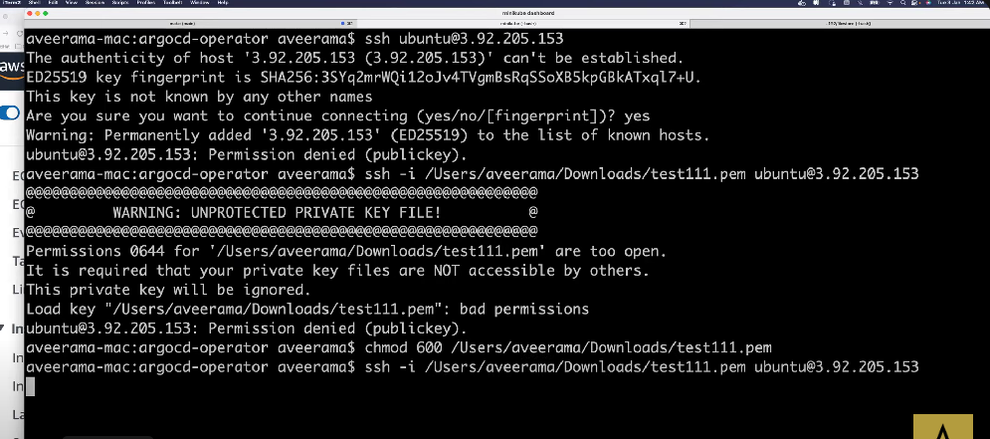

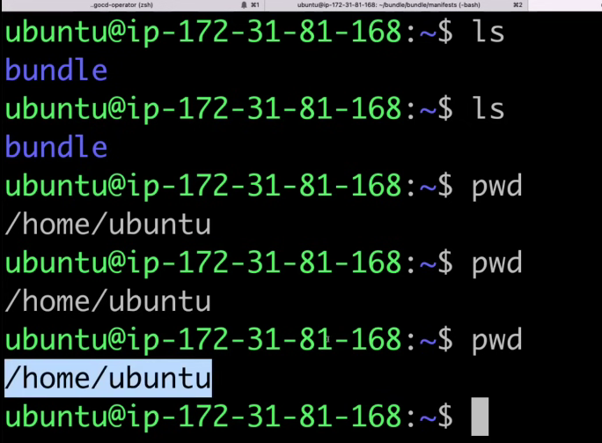Understanding distributions helps users pick the right one for their needs, whether they want a beginner-friendly desktop OS, a stable server environment, or a cutting-edge development platform.

Now I am connected to ubuntu server by Iterm2. Firstv when u go to the terminal we don’t know where we are . if u give “ls” command it will give all files. If windows means we have grapgical interface we can see so. Here type”pwd’’ present workig directory. It will give path where we are . after connecting to server user use command for update “sudo apt update”

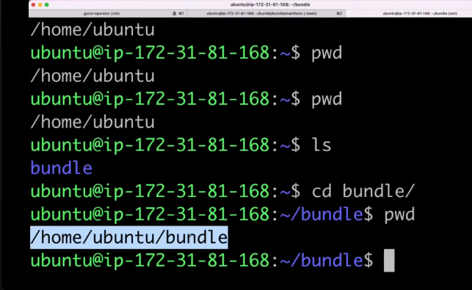Now if you want to open another directory we use cd command. I want to go to bundle directory .so use this command.

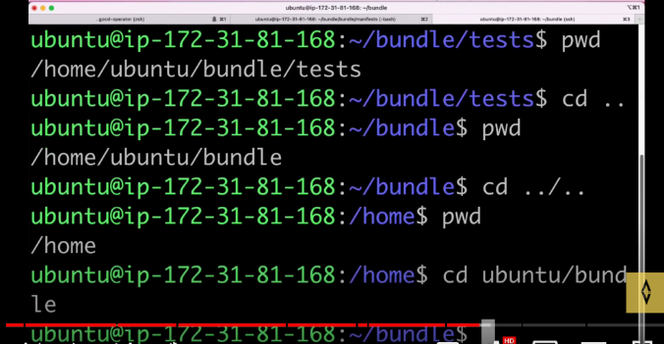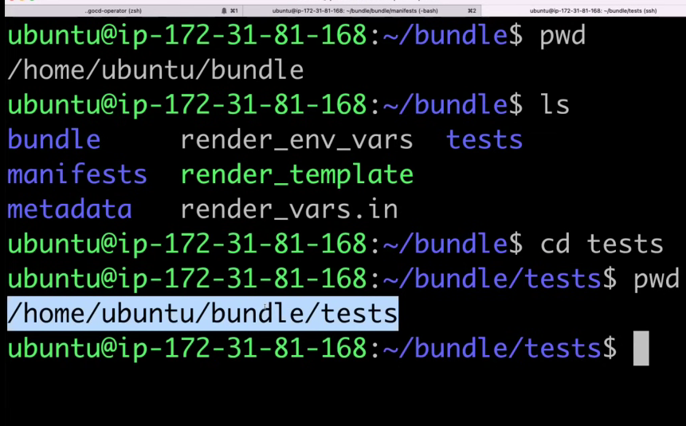

For going back we use command “cd ..” . for two folders we use another cmd, fo r directory change we use another cmd. For cleaning we use “clear” command.

Now I want to list all files with timestamp and other information like is it a file or directory.

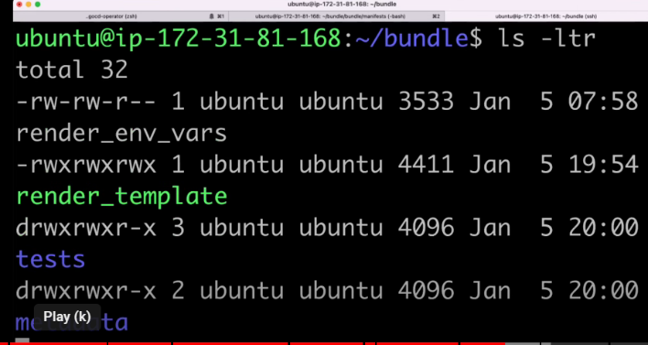here it starts “d” in drwxrwxr –it means it is directory.here ex tests is adirectory.if it doesn’t starts with d it is file here manifests is a file starts with “-”

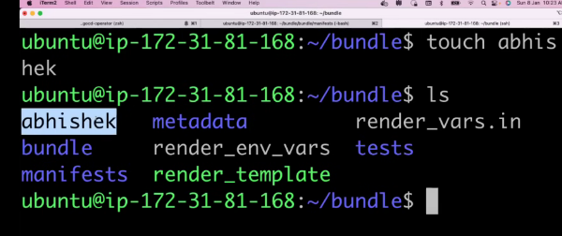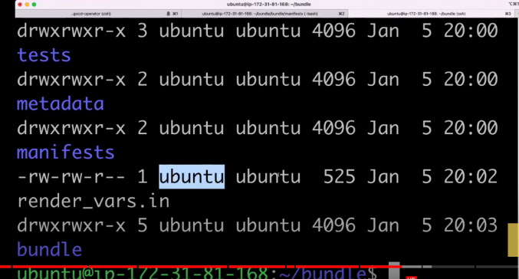

For creating files we touch command.we wiill use “vi” command it is not only creating the files but it opens the file to write anything. 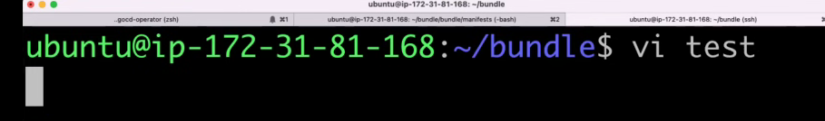

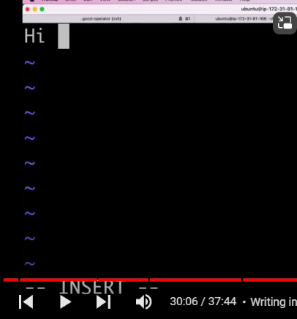for writing into this file .click “ESC” and “I”. it comes to insert mode. Now u can write the anything.

For saving what u have written use “esc” :”:wq!”

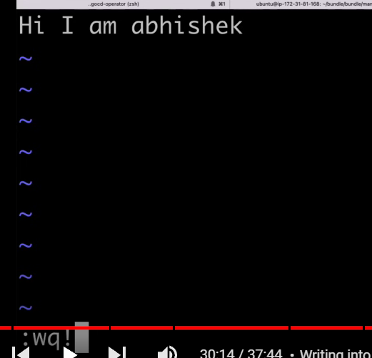

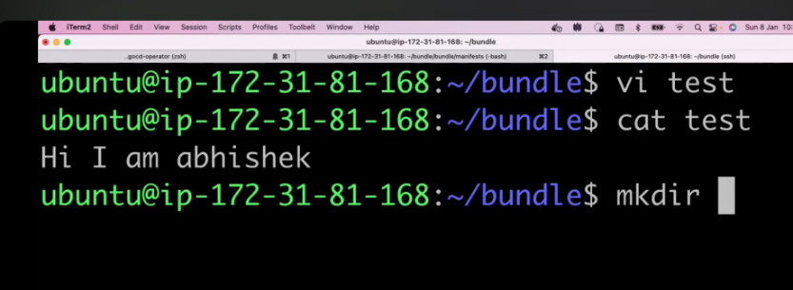For seeing the data we use “cat” command. For creating directory we use “mkdir” command. For removing a file we use “rm filename”. For removing we use “rm -r directoryname”

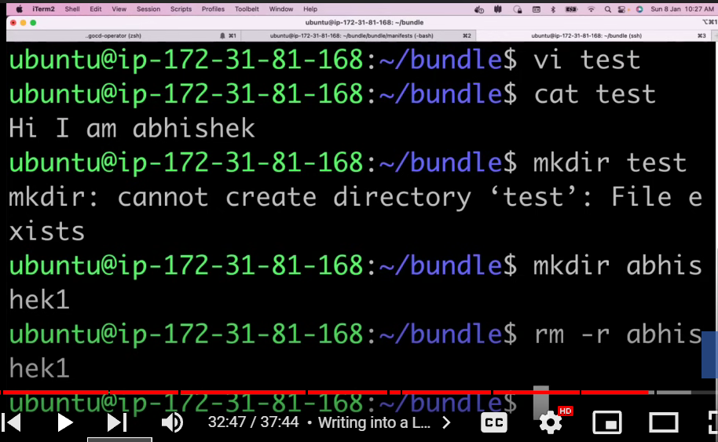

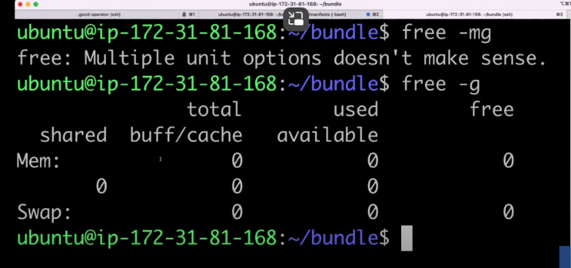If u are using windows. If u want to check system properties like memory, ram..etc. we used to go ssytem properies we will check. But for Linux we use command . for memory how much. For cpu’s. how many cpus’s u are using “nproc”. For disc size we use command “df -h”

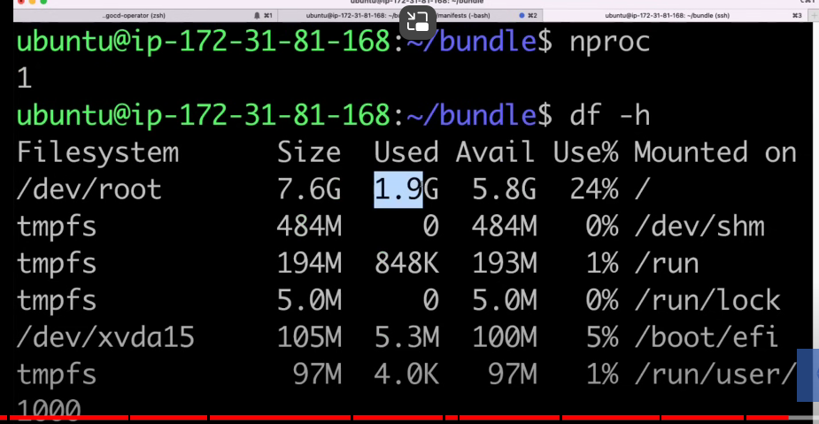

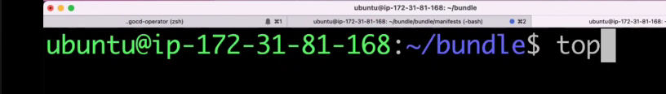

For seeing all properties we use “top” command.

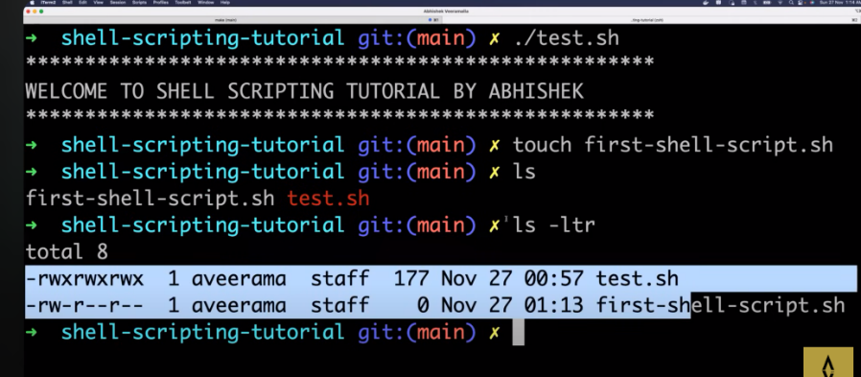**SHELL SCRIPTING:**

If u want to create a file. We use “touch” command. If u want to execute multiple commands at atime. We write all commands in file .if commands in python we use “.py”, if java means we use “.java” .so here we are using linux commands so “.sh”

**Creating and Running a File with Commands:**

1. **Creating a File with Commands:**
   * **Touch Command:** You can use the touch command to create an empty file in Linux.
     + Example: touch myscript.sh creates an empty file named myscript.sh.
   * **Writing Commands in a File:** Instead of running multiple commands one by one in the terminal, you can write them in a file. This file is called a script.
2. **File Extensions:**
   * **Python Scripts (.py):** If your commands are written in Python, the file typically has a .py extension (e.g., myscript.py).
   * **Java Files (.java):** If your code is in Java, the file has a .java extension (e.g., MyProgram.java).
   * **Shell Scripts (.sh):** If you’re writing commands for a Unix-like shell (like Bash), the file usually has a .sh extension (e.g., myscript.sh).
3. **Why Use .sh for Shell Scripts:**
   * **Shell Scripts:** When you write a series of shell commands and save them in a file, you typically use the .sh extension to indicate that it’s a shell script. This makes it clear that the file contains commands meant to be run in a shell like Bash.

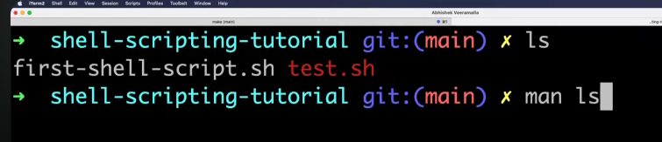

If we give “man” word in front of any command it will give the discription about the command.

-if u want to copy any file just double click on it. For opening the file we use “vi” or “vim” . if file is not there it automatically creates the file.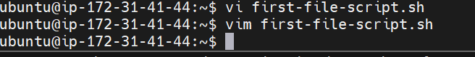

you might get this question but touch command is basically used in your automations so it is very important to learn the touch command and if it is very important to remember the touch comment because whenever you are doing automations you cannot use the Vim command because Vim is basically used to write inside a file but whenever you whenever you're doing some automations like you might have you have you might have a requirement to create thousand files okay for some random reason let's forget about the reason but somebody comes to you and says Abhishek create thousand files now you cannot create no you cannot use Vim inside your script because Vim opens the file okay it creates and also opens the file what happens if the file is opened let's say uh you have a Windows laptop andI'll play 1000 movies at once what happens your machine gets crashed okay similarly even in Linux you cannot opena lot of files and if if a lot of files are open then it's a problem or uh what happens if a movie is opened and left like that and if you try to close that process window says that okay this process is used by somebody else first close that file and then only you can close this process right where let's say you're watching a movie and you want to close the uh mp3 mp3 or MP4 player that you are using so what when you try to close the MP4 player what your windows says okay you cannot close the MP4 player because somebody is using the MP4 player similarly you cannot keep a lot of files open okay so that is why we also use Touch command .if any one writing shell script they will use file . it means shebang (“#!/”) folowed by any name s they will write.

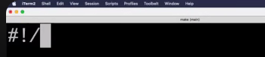

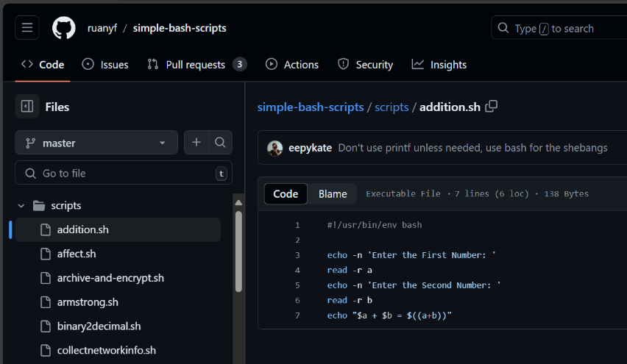They will write like “#!/bin/bash” or “#!/bin/ksh”…etc this is the first line everybody writes in their shell script. If we open any shell script in github we can it starts with shebang.

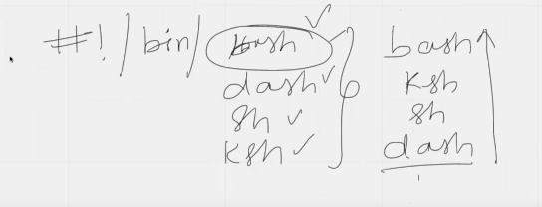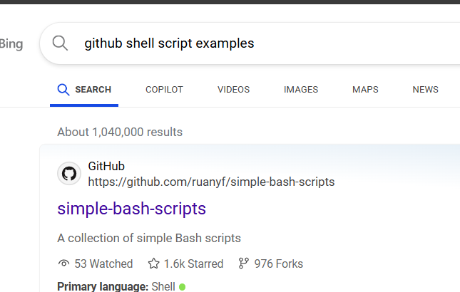

Your explanation is on the right track, but it can be refined for clarity. Let me break it down and explain each part: people uses shebank at first of file these are different executables.

**Shebang (#!) in Shell Scripts:**

* **Purpose of Shebang:**
  + The **shebang** (#!) is used at the beginning of a shell script to indicate which interpreter should be used to execute the script. It is followed by the path to the interpreter, such as /bin/bash, /bin/sh, /bin/dash, etc.
  + For example, if you write #!/bin/bash at the top of a shell script, it tells the system to use the Bash shell to execute the script.
* **Why Use a Shebang?**
  + The shebang ensures that the script is executed with the intended shell, regardless of which shell you are currently using in your terminal session.
  + It’s important because different shells (e.g., Bash, Dash, Ksh) have slightly different syntax and capabilities. The shebang ensures the script runs with the correct interpreter.

**Different Shells (Bash, Dash, Ksh, etc.):**

* **Bash (Bourne Again Shell):**
  + **Bash** is one of the most widely used shells on Unix-like systems, including Linux. It is powerful and offers a rich set of features, making it popular for writing shell scripts.
* **Dash (Debian Almquist Shell):**
  + **Dash** is a lightweight shell that is POSIX-compliant. It is faster and more minimalistic than Bash but has fewer features. It's often used as the default /bin/sh in some Linux distributions, particularly in scripts where speed and efficiency are prioritized over advanced features.
* **Ksh (KornShell):**
  + **Ksh** is another Unix shell that was widely used in the past. It has its own set of features and scripting syntax. While not as common as Bash today, it is still in use in some environments, especially where legacy scripts are involved.
* **Sh (Bourne Shell):**
  + **Sh** is the original Unix shell, also known as the Bourne shell. It is more basic and has fewer features than Bash. The sh shell is often used in scripts that need to be highly portable across different Unix-like systems.

**Choosing a Shell:**

* **Bash is Commonly Used:**
  + **Bash** is the most widely used shell today, especially for writing scripts. It has a rich set of features and is compatible with most Unix-like systems.
* **Legacy and Portability:**
  + **Sh** or **Dash** might be used for scripts that need to run on a wide variety of systems or where minimalism is important.
  + 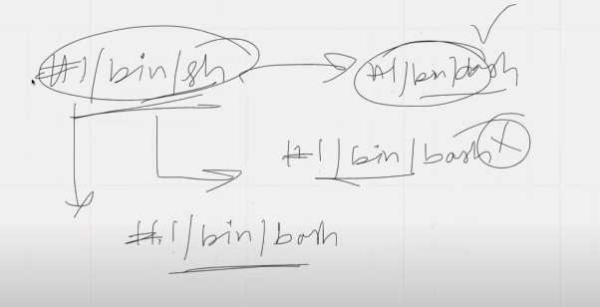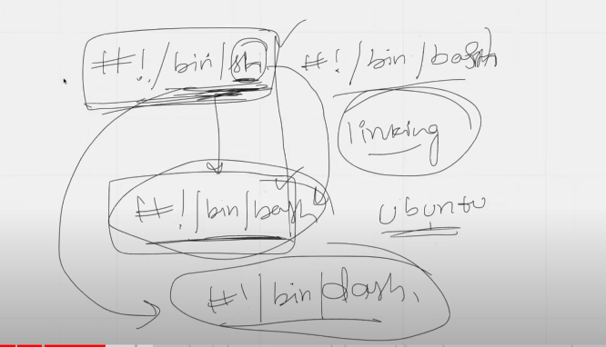**Ksh** might still be used in legacy systems, but it’s less common today.

what is the difference between sh and Bash now previously I explained you what is the difference between ksh bash and uh also the other why people are using

slash sh also for using the Bash scripting even though people are using bash scripting they sometimes use sh so if you if you again go back to the history of Linux so slash bin slash sh is something that redirects to your like even though they are providing slash bin slash sh so there is a concept in Linux called linking so there is soft link called linking so using linking even if you are providing this one this previously it was redirecting to slash bin

slash bash that means so even though you are providing this the request is taken by sh but it is forwarded to bash okay so it is using the concept of

linking okay so don't worry if you see sh or bsh in your previous scripts the scripts that were written uh previously in your organization so uh if you see Slash bin sh and uh if you think that it is executing bash that is because of the linking concept that is provided but but but these days like over couple of years I can say or like just uh previously in a year what happened is some of the operating systems like Ubuntu they have started using I mean they have started linking Dash slash Win slash sh two slash bin slash Dash so instead of bash they started using Dash as the default now why they are using it is out of scope of this video but you have to understand that now you cannot use this syntax so you have to be very careful if you are writing a back scripting always use slash bin slash bash okay so do not complicate the script or if you uh like you know if you start writing this one your script might might not work in some cases like uh in a Ubuntu machine likeyou share your cell script you write a bash scripting and you share your scale scripting to one of your colleagues and inside their machine slash bin slash sh if by default it has set a link to slash bin slash Dash your script will not work okay so that's why you have to be very careful so always the linking for slash bin slash sh is not pointed to slash bin slash Bash

**Shebang (#!) and Linking in Shell Scripts:**

**What is #!/bin/sh?**

* Historically, #!/bin/sh was used as the shebang in many Unix-like systems. The path /bin/sh refers to the Bourne Shell (original Unix shell).
* Over time, /bin/sh became a standard location for the shell interpreter, but not necessarily the Bourne Shell. Depending on the system, /bin/sh might be linked to different shell interpreters, such as Bash or Dash.

**What is #!/bin/bash?**

* #!/bin/bash explicitly tells the system to use the Bash shell to execute the script. Bash is a more advanced shell with additional features compared to the original Bourne Shell.

**Linking in Linux (Soft Links and Hard Links):**

* **Soft Links (Symbolic Links):**
  + A soft link (or symbolic link) is like a shortcut. It points to another file or directory. In this context, /bin/sh can be a symbolic link to another shell interpreter like /bin/bash or /bin/dash.
* **Hard Links:**
  + A hard link is a direct reference to the data on the disk. It is less commonly used for shell scripts.

**Why #!/bin/sh Could Behave Differently:**

* **Linking to Bash:**
  + On many older systems, /bin/sh was linked to /bin/bash. This meant that scripts written with #!/bin/sh were actually executed by the Bash shell, even though they were intended to be more portable and compatible with the original Bourne Shell.
* **Linking to Dash:**
  + On more modern systems, like some versions of Ubuntu, /bin/sh is linked to /bin/dash. Dash is a smaller, faster, and POSIX-compliant shell, but it lacks some of the advanced features of Bash. This can cause scripts written with Bash-specific syntax to fail when executed with Dash.

**Why It Matters:**

* **Portability:**
  + Scripts written with #!/bin/sh are generally intended to be portable across different Unix-like systems. However, if those scripts include Bash-specific syntax, they may not work correctly on systems where /bin/sh is linked to Dash or another shell that lacks those features.
* **Best Practice:**
  + If you’re writing a script that relies on Bash-specific features, it’s best to use #!/bin/bash as the shebang. This ensures that the script is executed by Bash, regardless of what /bin/sh is linked to on the system.
* 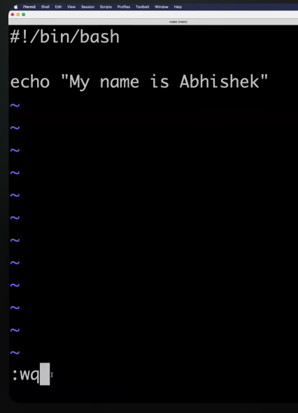whenever somebody is executing the shell script it has to print my name is Abhishek so every time people can't write right every time like you say 100 people have to write this thing so you are given an automation that write a small shell script that will enter I mean whenever you execute the cell script it has to print my name is Abhishek

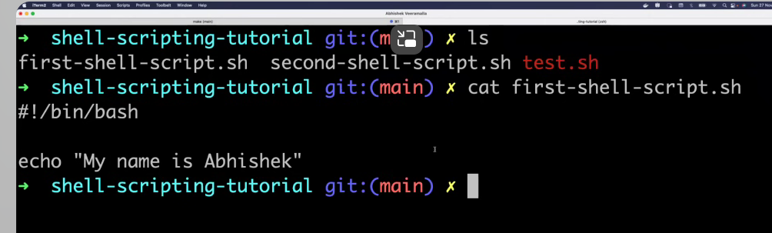

For executing the file we use “sh fileName” or we can use “./ filename”. “./” is used to run any executable file like java or python. If u want to use execute only shell we use “sh”





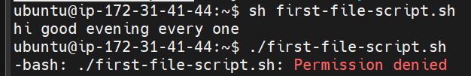

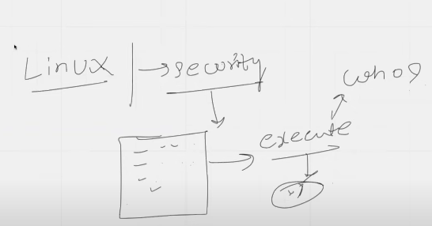Here 2nd one is giving permission denied.

the file you wrote something in the file but Linux the main purpose is security okay so Linux is very very secure so as soon as you open a file you write something in the file okay you create this file what Linux says is as soon as you save this file and you try to execute this file using dot slash or sh index is okay wait look before I execute this one I need to know who can execute or it asks who are you do you have permissions only if you have permissions I can allow you to execute this file so for that whenever you create a file you have to Grant permissions to your file .In linux granting permission is not straight forward. on Windows machine even in Windows you can do it like you know you can right click and you can say who which user has access which group has access .but for lunix we don’t have GUI. So we have to use the command line only.

-so for granting permission to a file we use “chmod” command . here “ch” stands for change . we are changing the permissions of a file.

Chmod provides permission to a file. It is divide into three categories, first category is what are the permissions for the administrator user . second is what are the permissions for the group third is what are the permissions for you.  these are how the three categories are divided because administrator should have access to a file a group should have access to a file and personally you should also have a access to your file because you are the creator of the file or you are the one who is using this file so by default. In Linux we will grant permission by using numbers.

by default if you want to Grant access to everybody you can simply say chmod 777 followed by the name of the file so now if I try to use the file gets executed and it printed whatever you wrote in the shell script

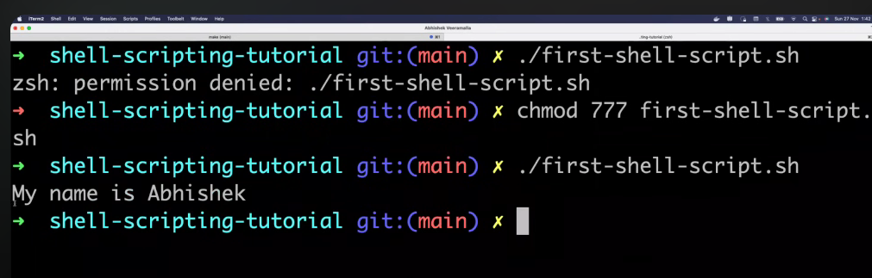

If u want to learn more about “chmod” use command “man chmod”.

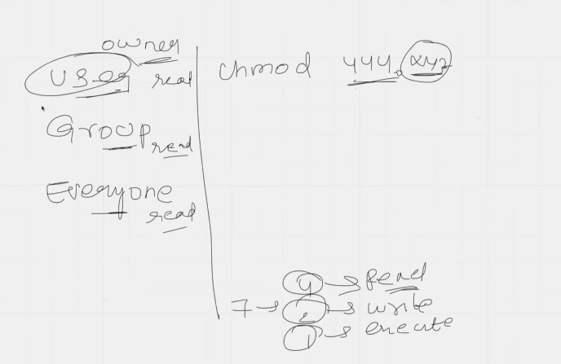

4->read , 2->write, 1->execute

Here 444 means first 4 refers to giving read permission to user(owner).next 4 is giving read permission to group of people. Third 4 is giving read permission to everyone

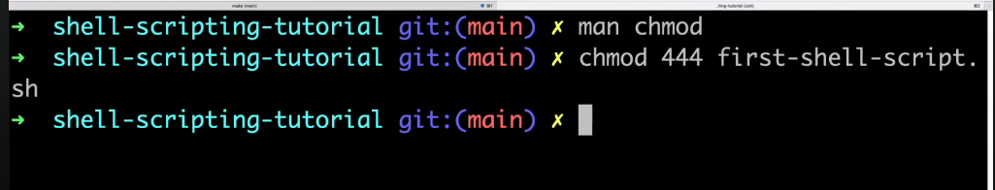

Know I change the permission to only read. If I try to edit this file means. If I edit and execute it wont execute. Because we given the permission for only read. So change it again “chmod 777”. Now it will execute.

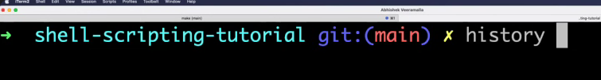

“history” command will give u history of all commands that u have entered.

For know where we are like listing current working directory we use “pwd”

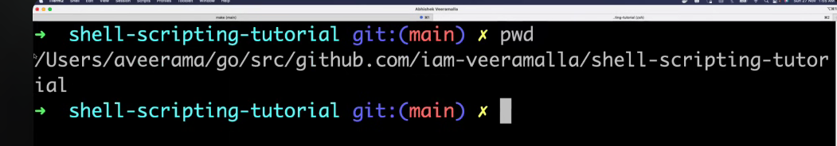

For creating folders we have “mkdir”

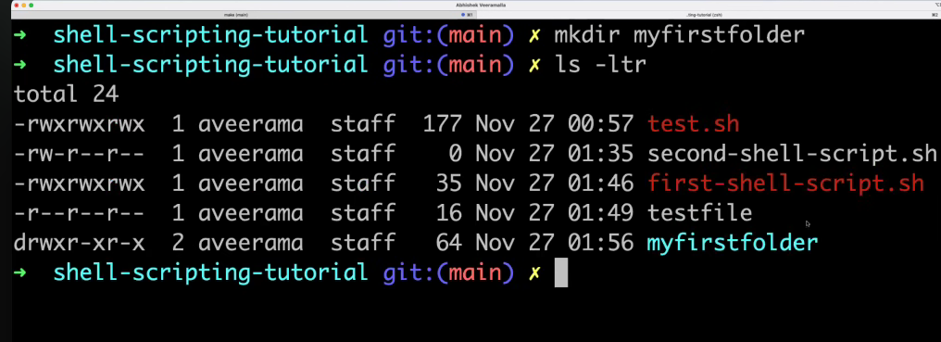

For changing the directory w use command “cd”

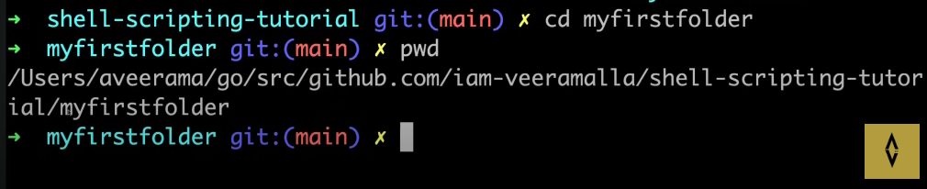

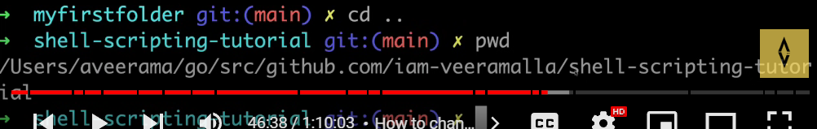

For deleteing a file “rm filename” . for folder “rm -r filename”

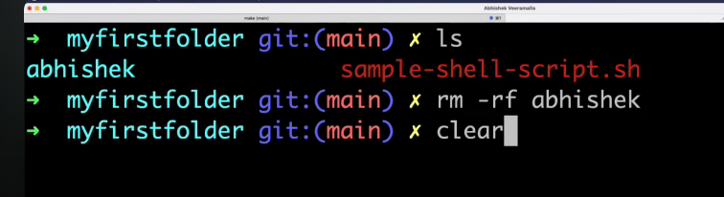

now I'll simply write a shell script to create a folder to create a file so every time this shell script executes it has to create a file it has to create a folder and inside this file you know we'll also change the permissions of this file and finally you know we'll see if the uh everything got executed or not using the cell script . now I will use “vim” command for opening the file

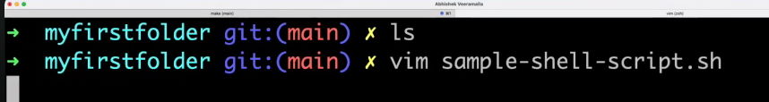

I will start writing by using SHEBANG.(#!/bin/bash) wriiting comments is good practice. We will write the comments using “#” . these are not executed by shell script.here bash is the shell script. These wont execute the comments .

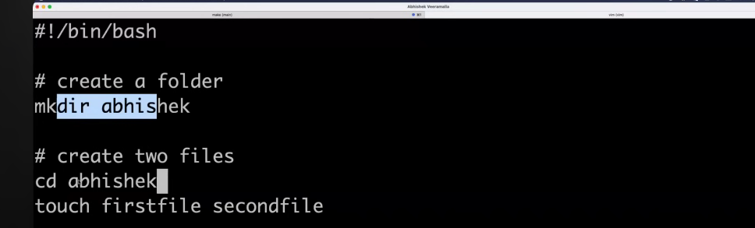

Here I am creating a folder and I am going inside this foldet and creating two files.now save and give permissions to this file.i am granting all permissions “chmod 777 simple-shell-script.sh”

Now execute the script “sh simple-shell-script.sh”. now if execute “ls” it will create a directory and inside two files.

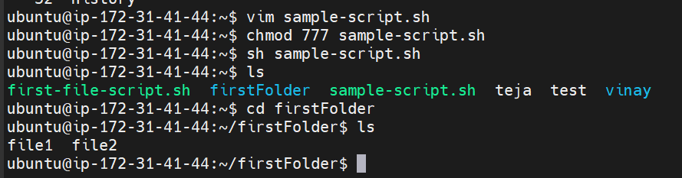

-now we will see scope of shell scripting iin devops

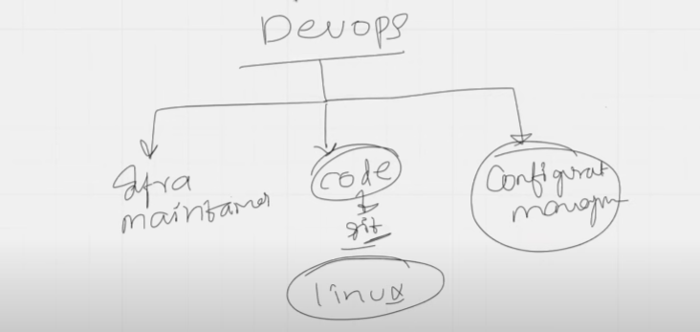

As a devops Engineers so you have different activities like you have infra maintenance right you maintain all the infrastructure of your organization you maintain all the code of your organization using git repositories okay so sometimes you have to interact with Git so again to interact with Git you use the Linux only right like you can ask me that why cannot why can't I do it using Windows but most of the organization prefers to use Linux because of the security and lightweight nature of Linux so you might use Linux windows on your laptop but if you are using any virtual machine so it will most probably be a Linux machine so you also manage your code using gitrepositories and that is also mostly on Linux and apart from this you also do a lot of configuration management so for all of these purposes on a day-to-day basis you use shell scripting okay so infrastructure automation is there configuration management and also your code management using git repositories so you can say that there are different tools like ansible that are available here but even though these things are available you have to write some shell scripts for regular automation of cron jobs or you know for uh switching into the folders where the sensible scripts are available or directly executing uh that like you know directly log into this machine uh on asingle automation what a user expects is you have to log into a specific machine where ansible automation is present and you have to execute the ansible automation as well or you want to monitor the health of your nodes .

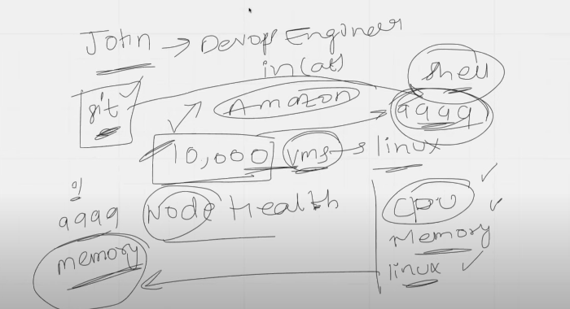

As a devops engineer in or it Amazon this is just for an example okay he's working as a devops engineer for Amazon and he has noticed that Amazon has close to 10 000 virtual machines this is just for an example okay or the teams that he is working with has 10 000 VMS what are VMS virtual missions and all of these VMS are Linux based VMS okay love for some reason he has to manage all of this 10 000 virtual machines and he has to monitor the node health of all of these virtual machines okay so every time he has to go to these virtual machines and uh their developers are facing some troubles with this node that they say that okay this virtual machine or any of these virtual machines is not performing as expected they say that the CPU is going out CPU is getting completed or they say that memory is running out or they also mentioned that you know the Linux is uh becoming very slow or they say that whatever the processes that are running on these virtual machines are basically running slow so every time John goes to these machines and uses the Linux commands to fix all of these things what he will instead do is he

will make use of shell scripting okay so he will write one simple cell

script and he'll save the cell script in a git repository and whenever some devops engineer says that okay there isissue with 9999 VM what he'll do is using the shell script he will just execute the shell script on his local machine and what the cell script does is it logs into this one of these he mentioned that 9999 mission is not working so this shell script automatically logs into this machine and it looks into all of these parameters like CPU memory and why are the processes going slow which files are running how many files are open on this machine so he writes a shell script and this shell script returns an output saying that okay so I executed this script and you know what I noticed is the memory is completely used on one of these nodes

okay so it returns whenever he runs the shell script it says it evaluated all these parameters and it says on 9999th machine he said that the memory is going out of place so the memory is completely used or instead of these people raising

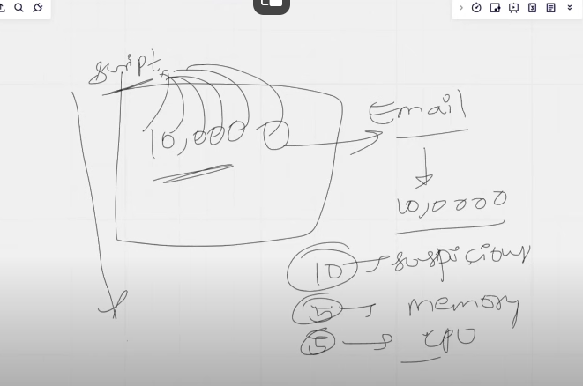

what John thought is okay okay I'm getting all of these requests like every time I'm getting requests from the developer saying that the memory is completely used so now let me uh do a simple thing that on a frequent basis like once every day or once every two days he decides to basically execute this script automatically okay so without even his consent this script should get executed and this script should look at all of this 10 000 VMS okay like I mentioned there are 10 000 VMS what this script should do is this script should log into each of these 10 000 machines look at the status of each of these 10 000 machines and it has to send out an email notification saying that hey John I evaluated all your 10 000 machines and out of which 10 machine seems to be suspicious okay 10 Mission seems to be suspicious and in five machines there is issue with memory and in five machines there is issue with CPU so this is one of the use case for devops engineers so similarly there are multiple use cases for devops engineers with shell scripting and shell scripting is a must learn for devops engineers .

**SHELL SCRIPT PART2**

we will try to run a custom node script and this node script will detect the node health of your virtual machine .

so let's say we will write a shell script we will use this shell script in our we'll try to put it in arcade repository and whenever somebody comes to us and says okay Abhishek I want to understand what is going wrong on my virtual machine there is something that is not correct so can you please help me out what you will do you will download the script from your Google uh sorry from your GitHub and you will directly execute it and it will send out all the details saying that okay some things is suspicious with respect to the memory or CPU .

for that we will write open file

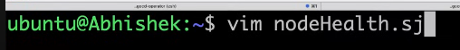

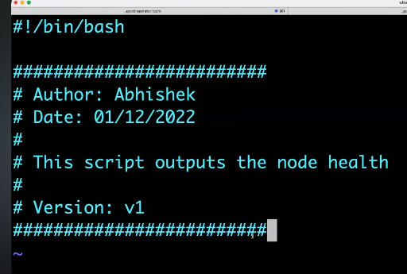So start with shebang. Next n the previous class we did not discuss about this but you always have to mention the details of Good Practices in writing a script this shell script the details as such who is the author provide those things in comments

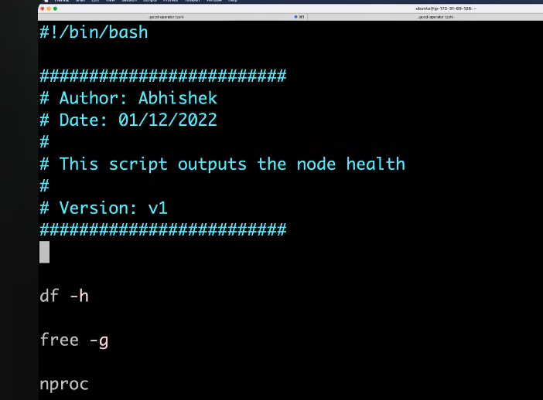

Next provide the commands and then next give the permissions and next execute the script.it provides the information but it is complex to understand because it is some what technical

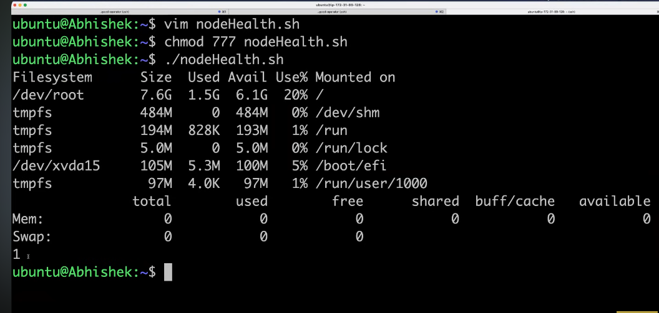eeeeeeeeeeeeeeeeeeeeeeeeeeeeeeeeeeeeeeeeeeeeeeeeeeeeeee

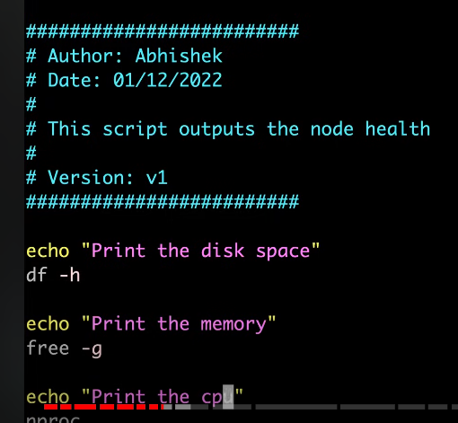for writing efficiently we use echo statements.now we can understand

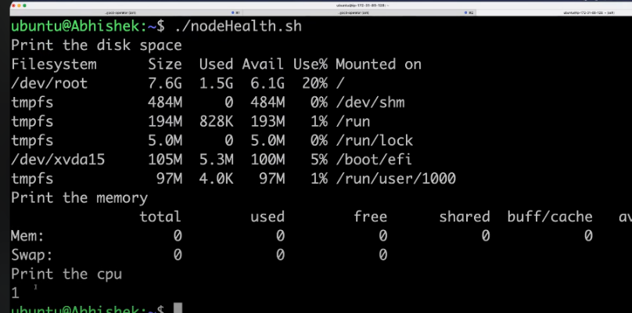

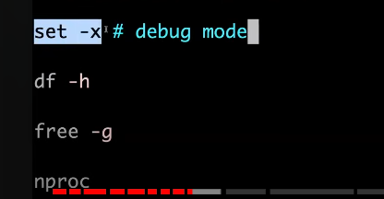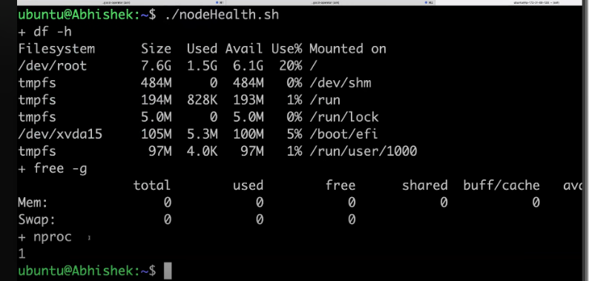Now it is ok. But if 1000s of lines code is theremeans at that time. We cant write the echo statement 1000 times that’s we write “set” parameter for to set this shell script in debug mode. Now all the commands are executed in debug mode.that means command infront each output.

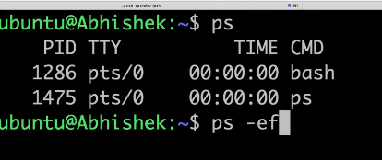Now I will write a command that will print all the process in that machine. Ex here in windows if u open yotube,face book now two proceese are running like in virtual machine a lot of process are working. Ex: u deplyed a amazon app inn virtual machinal that app consists of 300 microservices, exach microservice has different process one in login app, another Is payment like …etc. how do you find out what are the process working. In windows it is easy u will go to CLI u will search. But in linuc we don’t have GUI. For that w ehave a command . we can use “ps” it wont give full information “ps -ef” it gives the full information. Here it will give all processes . but if u want the specific processes for that use “grep” command . grep is doing the filtering. With “ps -ef” we get all information . next grep will filter based on what we provide. Here we 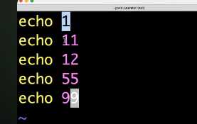are usinf “pipe” that is “|” here pipe is sending output of first command to second command. Example about pipe command

. if u want to print only numbers with 1.

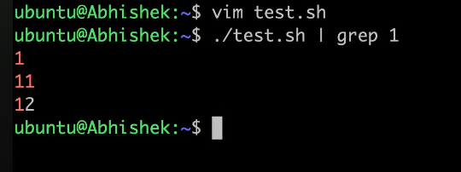

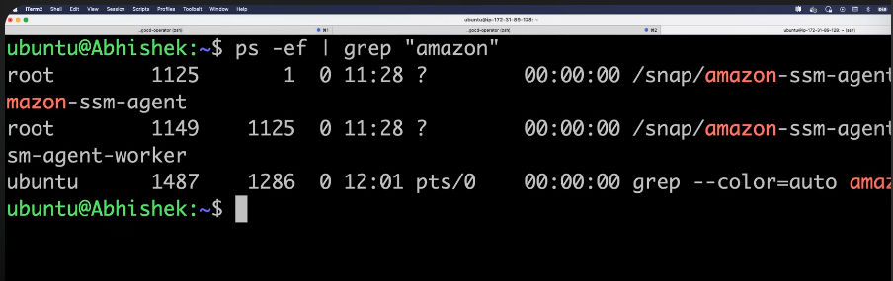

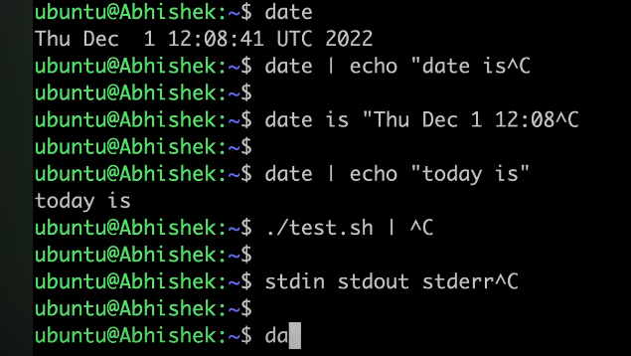 If you want only the process Id for killing the process. For doing something on this proceess we use Id of the process.here normally pipe send infromation from 1 command to 2nd command. But here date output is not sending to echo. We need to get the output like “today is 1 12:09:41” but we are not getting because date is default command it send sthe output to “stdin” . lets say we have three channels.stdin, stdout, stderr but pipe receives from only stdout. But date is sendijng to stdin. That is the reseason.

For getting “id” we have “awk” command. It will print only particullar column.

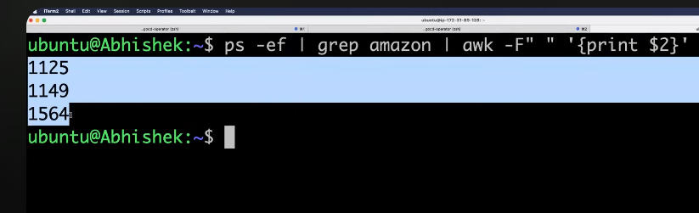

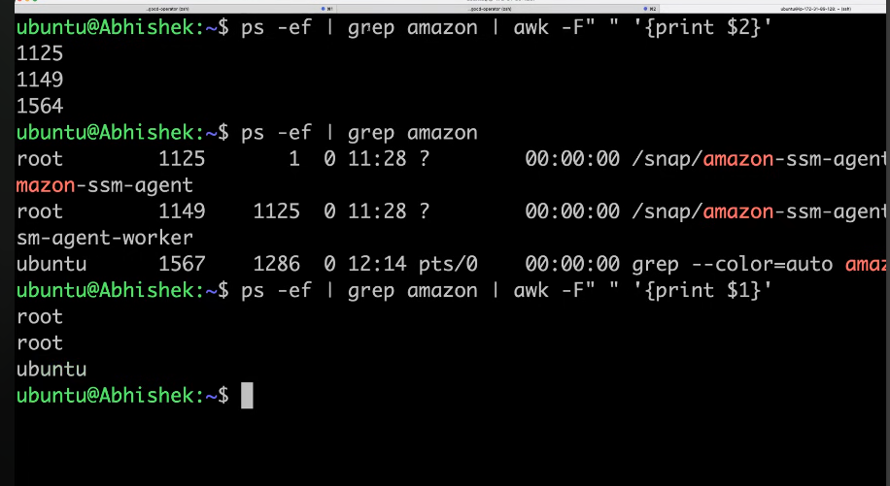

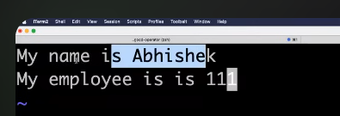

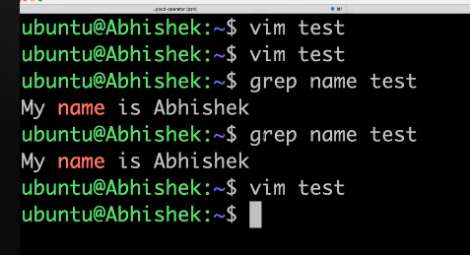

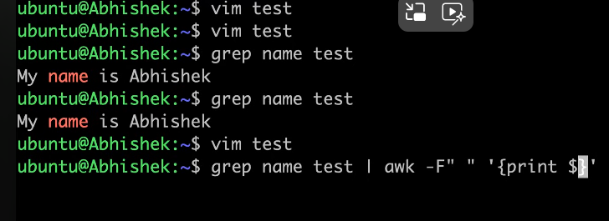

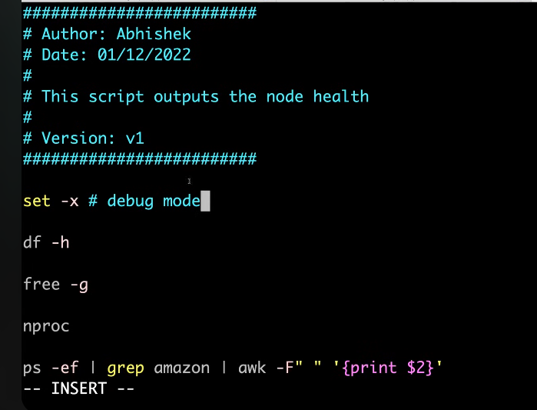

Whenever we are using in the script. You have to make sure that using a specific syntax called

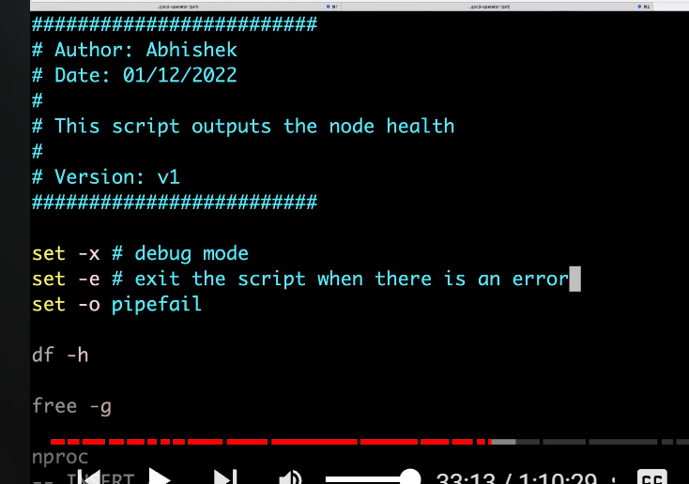

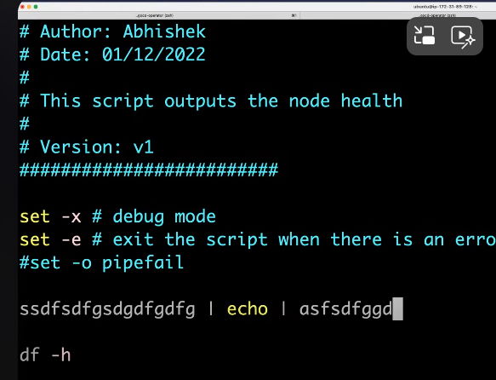What “set -e” will do is it exit the script when there is an error. If you are writing a 100 lines of shell script. If error is there at first line. Because of “set -e” it will it wont execute remaining line .if this command not there means it executes athe all the commands it is not good practice.herev drawback is “set -o pipefail” e have to put it as must. Because if u place it in comment that “set -o pipefail” . if there is any error in anyline that line using pipe means it executes ex:

“ssssss | echo”🡪it executes because it always checks last thing is working or not. “ssss | echo | ddlfnf” it gives the error .because lst command is something. It is drawback if don’t use “set -o pipefail”. So always try to enable it. We can all these in one command like

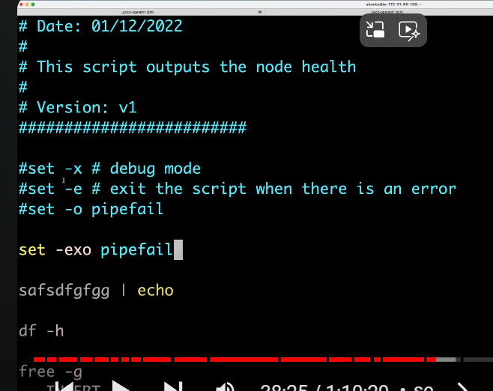

If any of the application is not working try check the log file. U will get details to solve the error.

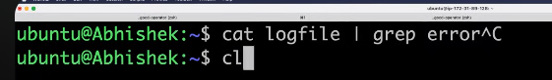

Whenever we append more and more logs.people usually uploads the logs to some external storage platforms.lets say u uploaded logs to some google storage. We will retrive the information by using “curl” command. Use “curl” command and provide the url to it.

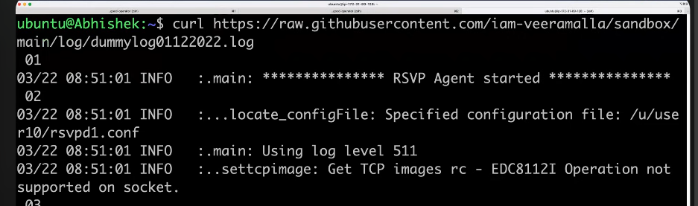

“Curl” command retrives the information from internet.

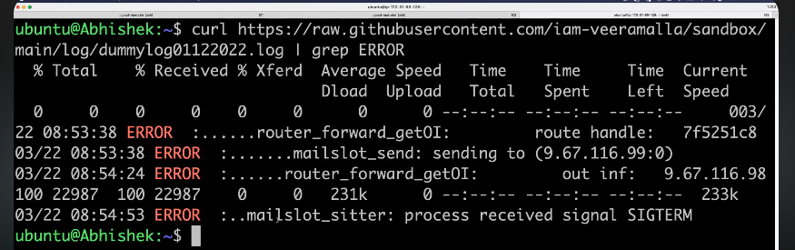

We can also make GET request for other application like google.com

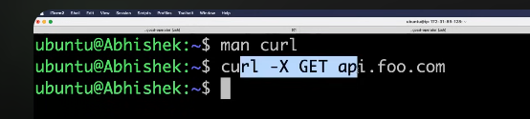

We have another command also . “wget” almost work like “curl” but using “wget” it will download and store the file.”curl” will share the information.

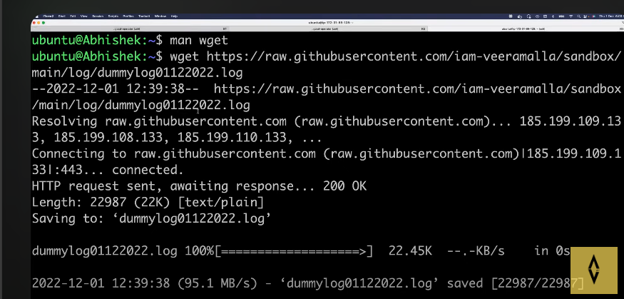

whenever you are in a Ubuntu user or any user usually you don't use root user in your organization because root is a very powerful user and you can delete anything and let's say you delete some important files and folders they cannot be retrieved back unless you have them in a monitored volume which has snapshots so if you case if we take care of a take a worst case using root you have deleted the file and there is no snapshots or it's not mounted on a volume what happens is the file is lost forever so that's why what you do and there are no backups also obviously if you have a backup then you can always retrieve it so in such cases what you do is always prefer using your personal user or a service account user that is provided to you . but as a devops engineer most of the times we will have access to the root user so how do we go to the root user is using this command .

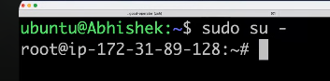

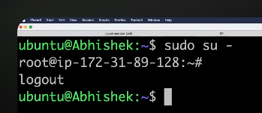

Here “sudo” means substitute user do.using sudo u can go to any other user.  and su means substitute user.

-“find” find command is used to find anything in the vm. Lets say u want to find the file.

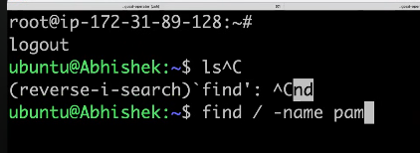

If I directly give command to find the file without switching to roor user..we weill get permission denied . because as a Ubuntu user I am not allowed to go and search of all of those files and folders .if I append sudo infront of it. We will get the files with name pam

.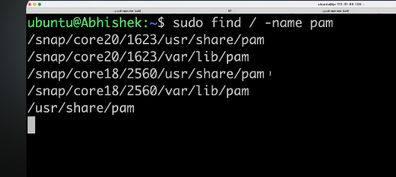

Now we will see if else conditions.

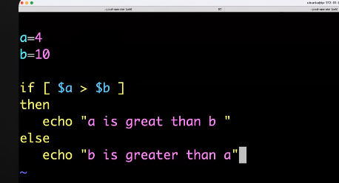

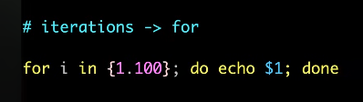

Finally we use trap command.”trap” command is used to trap the signal. We will use “kill command to kill a process by providing id”.

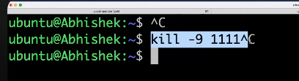

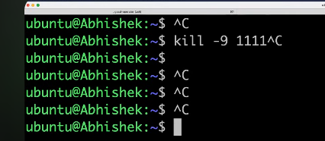

“Ctrl+c” is used to stop or terminate the script. you basically use the kill command -9 instructs the Linux compiler or the Linux kernel to say okay kill this specific process with this process ID so what is happening behind the scenes is when you are executing this command there is a signal that is passed to the Linux saying that okay so this person is asking you to kill a specific file so this is a signal and another thing is let's say there is a script that is getting executed what we usually do is to terminate the script we use Ctrl C okay so when you are pressing Ctrl C you are pressing it on your keyboard how does a Linux machine know that okay when you press Ctrl C I have to stop the execution of a script let's say uh I am printing something like this yes so this is a command and what this command is doing it is continuously uh inserting something on my terminal okay it is continuously printing if you see there is no end for this now I want to stop the terminal I want to stop this process or I want to just stop the execution of this process what I can simply do is I can come here and press Ctrl C so when I press Ctrl C what happened is there is a signal that this terminal has received or there is a signal that this Linux machine has received saying that okay so some person has executed Ctrl C and I have to start the stop the execution of this process so these are called signals. If somebody is asking you what are the different signals that are available in Linux you can say that there are a lot of signals that are there in Linux but we usually use some signals like we use the kill command to uh kill the process so uh then your Linux receives a signal called SIG kill . “check in google type signals of linux”

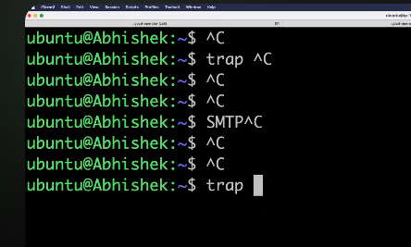

presses Ctrl C your script execution will stop for example yes is my script it keeps on executing something somebody came here and pressed Ctrl C the script execution got stopped which is not intended I don't want somebody to come to my machine and press Ctrl C and my script gets stopped so in such cases what you can do is you can trap the signal what is meaning by trap you can trap the Linux saying that okay even if somebody is pressing Ctrl C understand that I have a trap mechanism that is set on my machine and even if they press Ctrl C don't do anything or if they press Ctrl C send me a notification saying that on an email notification using SMTP server or you know just print an echo statement saying that oh you cannot use the Ctrl C because the owner of the Linux file the owner of the Linux machine said that he does not want to execute Ctrl C such things can be used by the Trap command Okay so trap signal is basically something that traps the signals and performs the execution on your behalf.

Ex



If somebody interupting with SIGINT signal(ctrl+c) I want to show a echo message.

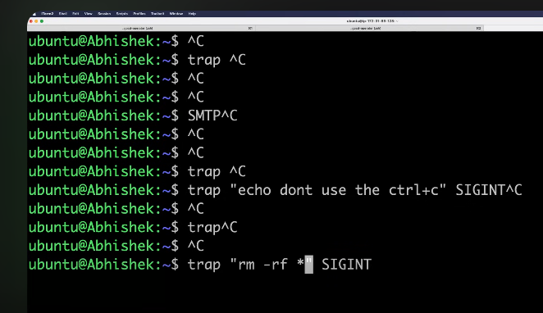

if somebody is executing a script and you are using Ctrl C and the half of the information is let's say there is a database and your shell script is trying to populate the list of users into your database okay and what happened is somebody came uh came to your terminal and they just use Ctrl C or unfortunately you use Ctrl C now what happens is only the half of the information is populated and the database uh user thinks that okay some information is there and this is the information I can start using so instead what you want to do is whenever somebody prints Ctrl C you say that delete every content so in such cases what you say is trap whenever somebody is using uh Sig int that is the control C what you have to do is RM minus RF star so if somebody is using Ctrl C delete everything from the database so that end user will not think okay uh some information is populated so I can start working this is the advantage of using a trap signal or the Trap command two trap signals on linux.